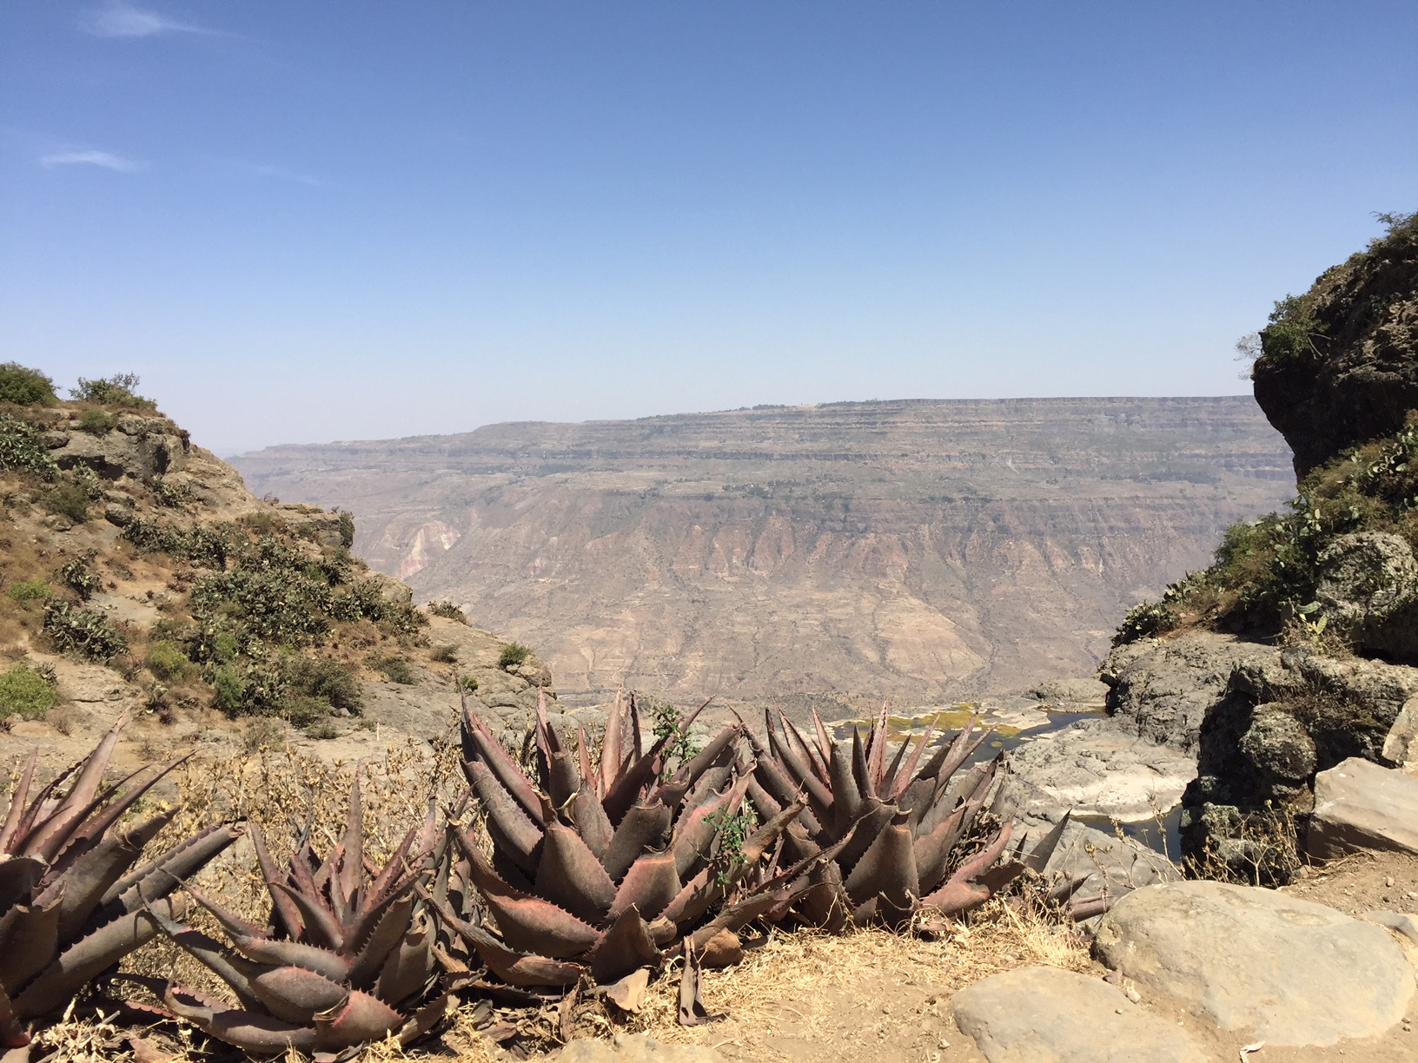
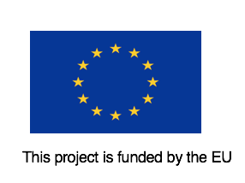
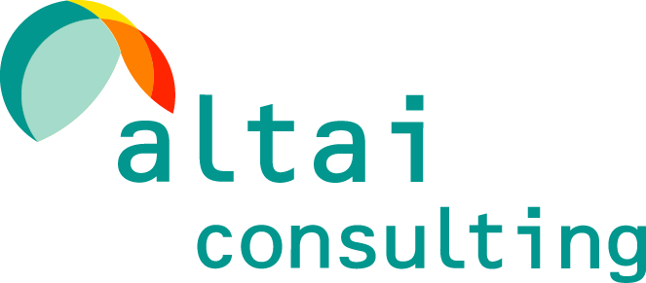
Altai Consulting for the European Union – May 2018
EUTF Monitoring and Learning System Horn of Africa:
Quarterly Report – Q1 2018
© European Union
May 2018

Unless specified otherwise, all pictures in this report are credited to Altai Consulting

Altai Consulting
Altai Consulting provides research, M&E and strategy consulting services to public institutions, governments and private actors in fragile countries and emerging markets.
Altai teams operate in more than 50 countries in Africa, the Middle East and Central Asia. Since its inception 15 years ago, Altai Consulting has developed a strong focus on governance, stabilisation and migration related research, monitoring and evaluation.

Contact Details:
Justine Rubira (Project Director): jrubira@altaiconsulting.com
Eric Davin (Altai Partner): edavin@altaiconsulting.com

www.altaiconsulting.com

Acknowledgments

This report was prepared by Eric Davin, Matthieu Dillais, Justine Rubira, Philibert de Mercey, Dhanya Williams, Bruno Kessler, Garance Dauchy, Cédric Ando and Mathilde Verdeil (Altai Consulting).
We gratefully thank project staff from the implementing partners who took the time to sit with us and comply with our reporting requirements. We are in particular indebted to: ACF, CARE, DCA, iDE UK, IRC, NRC, Oxfam, Plan and SCUK in Ethiopia; ADRA and GIZ in Sudan; FAO, GIZ, KRCS, RUSI, SAIDC with Farm Africa and Ten Senses, UNHCR, UNICEF and WFP in Kenya; ADA, DRC, Enabel and IOM in Uganda; DFID, Ecorys, Health Pooled Fund II and Mott MacDonald in South Sudan; Concern Worldwide, IDLO, IOM, NRC, UN Habitat, UNHCR and World Vision in Somalia; and GIZ, IGAD, IOM Horn of Africa and Sahan Research at the regional level.
We would also like to thank the EU delegations to Djibouti, Ethiopia, Kenya, Somalia, South Sudan, Sudan and Uganda.

Contents
1. Introduction 8
1.1. Background 8
1.2. The EUTF’s strategic priorities 9
1.3. The EUTF’s Horn of Africa window 9
1.4. The EUTF’s Horn of Africa window – Looking forward 10
2. The Monitoring and Learning System 11
2.1. Overview 11
2.2. Rationale & Positioning 11
2.3. Objectives & key steps 12
3. Detailed Analysis 13
3.1. Introduction 13
3.2. Overview 13
3.2.1. Overview of budgets and contracts by country 13
3.2.2. Overview by Programme 14
3.2.3. Overview by Strategic objective and EUTF common output indicator 19
3.2.4. Overview by Implementing partner 22
3.3. Analysis by country 22
3.3.1. Regional programmes 22
3.3.2. Ethiopia 28
3.3.3. South Sudan 36
3.3.4. Sudan 43
3.3.5. Somalia 49
3.3.6. Kenya 54
3.3.7. Uganda 61
3.3.8. Djibouti 68
3.4. Analysis by Strategic Objective 70
3.4.1. Greater economic and employment opportunities 70
3.4.2. Strengthening resilience of communities 72
3.4.3. Improved migration management 73
3.4.4. Improved governance and conflict prevention 77
4. Conclusions and perspectives 79
5. Index of figures, tables & focus boxes 82

Abbreviations and acronyms
€1B | One billion euros
€1M | One million euros
ACF | Action Contre la Faim
ADA | Austrian Development Agency
ADRA | Adventist Development and Relief Agency
AFD | Agence Française de Développement
AHA | Africa Humanitarian Action
AICS | Agenzia Italiana per la Cooperazione allo Sviluppo
AKF | Aga Khan Foundation
ARRA | Administration for Refugee and Returnee Affairs
ASAL | Arid & Semi-Arid Land
AVRR | Assisted Voluntary Return and Reintegration
BC | British Council
BMM | Better Migration Management
BTVET | Business Technical Vocational Education and Training
CARE | Cooperative for Assistance and Relief Everywhere
CIB | Caritas International Belgium
COOPI | Cooperazione Internazionale
CORDAID | Catholic Organization for Relief and Development Aid
CRRF | Comprehensive Refugee Response Framework
CVE | Countering Violent Extremism
CW | Concern Worldwide
DCA | DanChurchAid
DCV | Deutsche Caritasverband (Caritas Germany)
DG DEVCO | Directorate-General for International Cooperation and Development
DFID | UK Department for International Development
DICAC | Development and Inter-Church Aid Commission
DRC | Danish Refugee Council
DRC the | Democratic Republic of the Congo
DRR | Disaster Risk Reduction
ECC-SDC | Ethiopian Catholic Church – Social and Development Commission
ECHO | Directorate-General for European Civil Protection and Humanitarian Aid Operations
EEAS | European External Action Service
EECMY-DASSC | Ethiopian Evangelical Church Mekane Yesus Development and Social Services Commission
EIDACS | Enhancing Integration of Displacement Affected Communities in Somalia
Enabel | Belgian Development Agency (previously BTC)
EU | European Union
EUD | European Union Delegation
EUHQ | European Union Headquarters
EUTF | European Union Emergency Trust Fund for stability and addressing root causes of irregular migration and displaced persons in Africa (also EUTF for Africa)
FAO | Food and Agriculture Organization of the United Nations
FFS | Farmers Field Schools
FLASH | Facilitating sustainable return through laying foundations for Somalia in the Horn of Africa
GIZ | Deutsche Gesellschaft für Internationale Zusammenarbeit
gvt | Government
HDI | Human Development Index
HoA | Horn of Africa
HPF | Health Pooled Fund
HRIS | Human Resources Information System for Education
ICPALD | IGAD Centre for Pastoral Areas development and Livestock Development
IDDRSI | IGAD Drought Disaster Resilience and Sustainability Initiative
IDLO | International Development Law Organization
iDE | International Development Enterprises
IDP | Internally Displaced Person
IGA | Income-Generating Activities
IGAD | Intergovernmental Authority on Development
ILO | International Labour Organization
IMC | International Medical Corps
IOM | International Organization for Migration
IP | Implementing Partner
IRC | International Rescue Committee
KISEDP | Kalobeyei Integrated Social and Economic Development Plan
KRCS | Kenya Red Cross Society
KSA | Kingdom of Saudi Arabia
LVIA | Lay Volunteers International Association
M&E | Monitoring and Evaluation
MCMDO | Mothers and Children Multisectoral Development Organization
MLS | Monitoring and Learning System
MRC | Migrant Resource Centre
MSMEs | Medium and Small Enterprises
No | Number
NRC | Norwegian Refugee Council
OSHO | Oromo Self-Help Organisation
OWDA | Organisation for Welfare and Development
Q1 | First quarter
PWO | Pastoralist Welfare Organisation
REF | Research and Evidence Facility
RDPP | Regional Development and Protection Programme
RRF | Regional Reintegration Facility
RUSI | Royal United Services Institute
RVO | Netherlands Enterprise Agency (Rijksdienst voor Ondernemend Nederland)
RWC | Refugee Welfare Committee
SAIDC | Slovak Agency for International Development Cooperation
SC | Save the Children
SCUK | Save the Children UK
SO | Strategic Objective
SOAS | School of Oriental and African Studies
SPRS-NU | 'The Support Programme for Refugee and Host Communities in Northern Uganda
SSCoS | Strengthening social cohesion and stability in slums populations
SPN | Stichting Plan Nederland (also called ‘Plan’)
ToC | Theory of Change
ToR | Terms of Reference
TVET | Technical and Vocational Education and Training
UN DESA | United Nations Department of Economic and Social Affairs
UNDP | United Nations Development Programme
UNHCR | United Nations High Commissioner for Refugees
UNICEF | United Nations Children's Fund
UNIDO | United Nations Industrial Development Organization
UNODC | United Nations Office on Drugs and Crime
VAP | Valletta Action Plan
VoT | Victims of Trafficking
VSF-G | Veterinaries without Borders - Germany
WASH | Water, Sanitation and Hygiene
WFP | World Food Programme
WHH | Welthungerhilfe
WV | World Vision
ZOA | Zuid-Oost Azië

Introduction

Background
The European Union Emergency Trust Fund for stability and addressing root causes of irregular migration and displaced persons in Africa (EUTF for Africa or EUTF) was launched at the Migration Summit in La Valletta on 11 and 12 November 2015. With an initial total budget of approximately €2B and a duration of five years, the EUTF contributes to the implementation of the Valletta Action Plan (VAP).
The EUTF is composed of three geographical ‘windows’, each including the following countries:
- The Horn of Africa (HoA) window: Djibouti, Eritrea, Ethiopia, South Sudan, Sudan, Uganda, Tanzania, Kenya and Somalia.
- The North Africa window: Morocco, Algeria, Libya, Egypt and Tunisia.
- The Sahel and Lake Chad window: Mali, Niger, Senegal, Nigeria, The Gambia, Mauritania, Chad, Guinea, Ivory Coast, Ghana, Cameroon and Burkina Faso.
The overall objective of the EUTF is to address the crises in the Sahel and Lake Chad, the Horn of Africa, and the North of Africa regions (i.e. the three ‘windows’ of the EUTF). It supports all aspects of stability and contributes to better migration management as well as addressing the root causes of destabilisation, forced displacement and irregular migration, in particular by promoting resilience, inclusive economic opportunities, security and development. The EUTF is operated in coordination with national and regional frameworks and other European Union (EU) instruments, as well as those of other development partners.
As a whole, the EUTF works with twenty-six partner countries, which are facing growing challenges in terms of demographic pressure, extreme poverty, weak social and economic infrastructure, internal tensions and institutional weaknesses, insufficient resilience to food crises and environmental stress.
The consequences of such complex challenges are hugely varied and interconnected. Among others, they include open conflict, forced displacement, irregular migration, criminal activities and lawlessness, smuggling of migrants and trafficking in human beings, radicalisation and violent extremism.
The EUTF currently represents €3.3B pledged, including an approved amount of over €2.6B over 147 programmes and €1.6B signed across 226 contracts.
The EUTF has two governing bodies: the Strategic Board and the Operational Committee. The Strategic Board sets the global strategy of the EUTF, meeting at least once per year. The Operational Committee adopts the actions to be implemented on the ground, and meets at separate sessions for each of the three geographical regions. Both bodies are chaired by the European Commission and are composed of representatives of the European External Action Service (EEAS), EU and non-EU donors (as full members), and representatives of the concerned African partner countries and regional organisations (as observers), who are invited to actively participate at both levels.

The EUTF’s strategic priorities
Historically, and per its Strategic Orientation Document, the EUTF has focused on four strategic objectives (SO) or lines of action:
- SO1 ‘Greater economic and employment opportunities’: Economic development programmes addressing skills gaps, improving employability through vocational training and supporting job creation and self -employment opportunities with a focus on strengthening micro, small and medium size enterprises (MSMEs);
- SO2 ‘Strengthening resilience of communities and in particular the most vulnerable, as well as refugees and other displaced persons’, through improved food and nutrition security as well as basic services;
- SO3 ‘Improved migration management in countries of origin, transit and destination’, including addressing the drivers of irregular migration, effective return, readmission and reintegration, international protection and asylum, legal migration and mobility, and enhancing synergies between migration and development​;
- SO4 ‘Improved governance and conflict prevention and reduction of forced displacement and irregular migration’: Supporting improvements in overall governance, in particular by promoting conflict prevention, addressing human rights abuses and enforcing the rule of law.

The EUTF’s Horn of Africa window
The Horn of Africa region faces challenges that go beyond country borders: climate change, forced displacement, demographic pressures, environmental stresses, various forms of conflict, trafficking of human beings and smuggling of migrants, as well as organised crime and violent extremism. As of 2018, the Horn of Africa is said to host over 5.2 million refugees and 5.8 million Internally Displaced Persons (IDPs), the largest number on the continent, with no signs of improvement.
The EUTF’s approach to addressing these challenges is geographically comprehensive and holistic, putting the region at the centre of its response, for instance by working with the area’s regional organisation IGAD (Intergovernmental Authority on Development) and building on areas of work in which IGAD is active, such as durable solutions for refugees, peace and security and resilience building, and harmonisation of national policies and strategies.
The EUTF’s Horn of Africa window currently represents €1.3B in allocable contributions, of which €846M have been committed, and €516M have been signed to 74 contracts in 7 countries (there are currently no projects in Eritrea or Tanzania). The Fund’s first ten projects, totalling €253M, were approved at the first Operational Committee in December 2015 and the rest were approved at the following mostly biannual Operational Committees.
The operational priorities of the Horn of Africa window are outlined in the Operational Framework of the EU Emergency Trust Fund for Africa Horn of Africa window and follow two main intervention logics: a ‘migration and displacement’ logic, and a ‘stability and peacebuilding’ logic. All projects funded under the EUTF have to be designed and implemented in line with the principles of intervention set out in the EUTF Strategic Orientation Document.
In addition, over time, the EUTF’s Board has further honed the HoA window’s priorities, highlighting first, in June 2017, three strategic priorities for the Horn of Africa window and then, in April 2018, six criteria for the use of the Trust Fund’s overall resources.
The June 2017 three strategic priorities for the Horn of Africa are: i) to improve the management of refugees in the region; ii) to prevent and fight trafficking and smuggling, including along the Central Mediterranean Route and; iii) to increase stability in peripheral areas.

The EUTF’s Horn of Africa window – Looking forward
In April 2018 six complementary criteria were identified by the EUTF Strategic Board to drive the focus of the next set of projects to be funded. While they do not contradict the initial intervention logic of the HoA window portfolio, they shed light on specific thematic areas that will receive more focused attention in the future from the three EUTF windows:
- Return and reintegration, notably by rolling out a reintegration approach based on referral to national structures, thereby building the capacity of national systems and empowering governments in the long term to manage the reintegration process;
- Refugee management, notably in the HoA, ensuring that refugees have adequate protection and support for their long-term needs. The regional roll-out of the Comprehensive Refugee Response Framework (CRRF) has been pioneering and has provided the EU with a unique opportunity to leverage EU policy in a multi-donor context, including the implementation of the humanitarian-development nexus. The countries most affected in the HoA are Kenya, Uganda, Djibouti and Ethiopia (the only Partnership Framework country in the region);
- Completing progress on the securitisation of documents and civil registry. In the HoA there are no proposals related to this criterion. However, some activities in this area are being supported through the regional Better Migration Management (BMM) programme;
- Anti-trafficking measures, as migrants in the region are in grave danger of being exploited by traffickers and smugglers, who are increasingly well-organised. The EUTF is helping to disrupt these networks, through interventions that enhance government capacity to manage migration more effectively and to provide protection and by supporting processes such as the Khartoum Process and the Partnership Framework Approach. Migrants’ protection needs in Djibouti and Somalia in particular will be addressed;
- Essential stabilisation efforts in Somalia, Sudan and South Sudan. In Somalia, the EUTF will focus on stability-enhancing interventions such as support for a more vibrant economy and rule of law, including domestic resource mobilisation and state building through fiscal federalism. In Sudan, as a country of origin, transit and destination, the EUTF will provide basic services in key urban and peri-urban areas and protection of migrants and IDPs. In South Sudan, actions will be taken to encourage stability and build resilience in conflict-affected areas.
- Migration dialogue. As Ethiopia’s stability is crucial for the region as a whole, the EU has sought active dialogue with the Ethiopian government on migration issues. As part of this dialogue, the EUTF will support Ethiopia’s industrialisation strategy as a means of stimulating job creation for refugees and host communities alike, while the Ethiopian government has agreed to grant employment rights to tens of thousands of refugees.

The Monitoring and Learning System

Overview
In March 2017, the EUTF HoA team issued a tender for the Monitoring and Learning System (MLS). As described in the Terms of Reference (ToR), the overall objective of the MLS is to ‘use an evidence-based approach for programming and implementing interventions in the Horn of Africa region, as well as to inform policy around the themes of the EUTF in the region.’ Altai was awarded the contract and the project started on 5 July 2017.

Rationale & Positioning
The EUTF HoA portfolio will soon comprise more than 100 projects implemented in 7 to 9 countries, each with an average budget of €10M, and in many cases, large consortia of implementing partners (IPs) are involved. As a result, a large volume of reporting will be generated across the EUTF portfolio, and this will be difficult for the EUTF HoA management team to process. It will also be difficult to visually represent such a wide variety of projects and to track overall progress against a regional theory of change.
The EUTF monitoring component was therefore designed as a regional ‘meta-monitoring’ system to gather raw data from all projects on a quarterly basis, in a pre-defined format and based on a number of agreed indicators, and to cross-analyse and deliver the information in distilled quarterly reports and synthesised visualisations that can directly help decision-makers to monitor and improve the EUTF’s trajectory towards its impact objectives.
As represented in the diagram below, the MLS does not aim to replace or duplicate the M&E systems of each individual project or other existing mechanisms such as the Results-Oriented Monitoring (ROM), or internal evaluations planned for the EUTF at the regional or project levels. On the contrary, the HoA MLS will use data produced by internal project M&E systems and contribute to improving these systems where necessary.
Figure 1: Overview of the different layers of M&E in the HoA region
> On this basis the monitoring component of the MLS tracks progress made at the regional level in line with the EUTF HoA’s theory of change

Objectives & key steps
In addition to the overall objective stated above, the MLS aims to:
- strengthen monitoring and reporting on the overall progress of the EUTF HoA window;
- create a learning component based on investigations on projects to inform the programme strategy.
The approach detailed below presents the five expected results of the MLS:
Figure 2: Objectives of the MLS
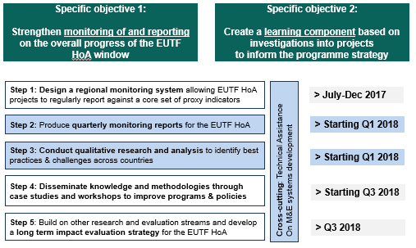
For further details on the approach and methodology of the MLS, see also sections 1.1 to 1.6 of the enclosed annexes.

Detailed Analysis

Introduction
This first quarterly report is to be considered as a baseline for the regional data provided, and the opportunity to pilot test the system of common output indicators that was developed by the EUTF in the last year. It is based on a combination of project data obtained from the EU with regards to budgets, figures, and output data collected from EUTF IPs and fed into the EUTF common output indicators, as further detailed in the Methodology section above.
While this first quarterly report focuses on showing progress so far, future reports will gain in breadth and depth as increasing numbers of IPs and more detailed information are included and the analysis becomes more complete.
Figure 3: Expected evolution in quantity and depth of information in EUTF quarterly reports
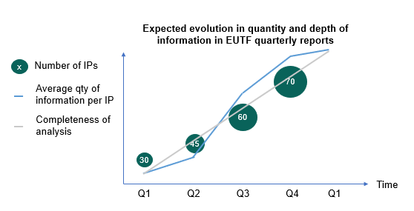

Overview

Overview of budgets and contracts by country
Of the €846M committed by the EUTF HoA window, €516M have been contracted to both regional projects (€166.4M) and projects implemented in 7 of the region’s 9 countries. The country with the most funds contracted out to projects is Ethiopia (€101.5M), followed by South Sudan (€75.0M), Sudan (€59.4M), Somalia (€51.1M), Kenya (€28.4M), Uganda (€24.1M) and Djibouti (€10.0M).
Figure 4: Budget contracted and number of contracts by country, May 2018
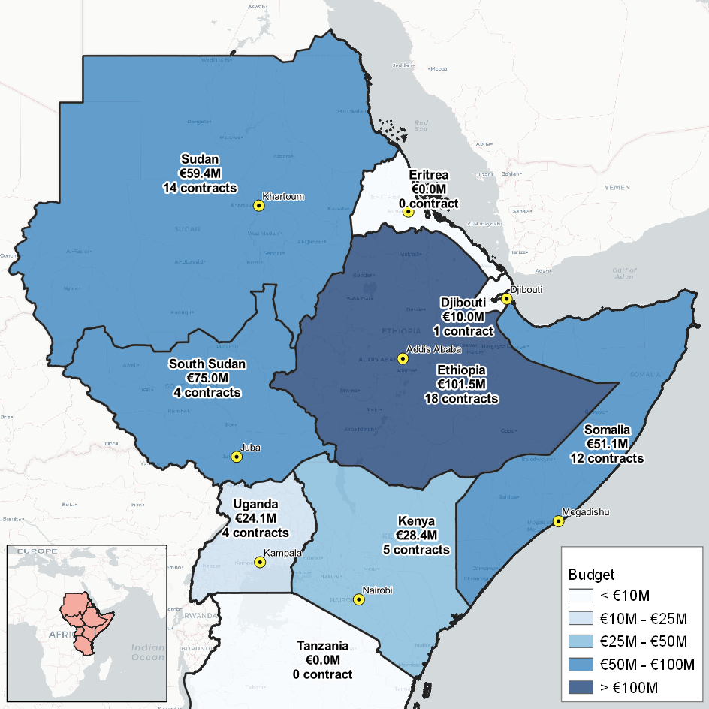

Overview by Programme
The first wave of programmes was approved in the first Operational Committee of December 2015. Since then, a total of 50 programmes have been approved and 74 projects contracted to 48 unique IPs. Since the first programmes and projects started in December 2015 and those recently signed are to end in 2021, with an average of 36 months per contract, the programmes and projects of the HoA portfolio cover a timespan of six years -and growing.
Of the 74 projects (see the report’s Annex for a full list of the 74 projects) contracted so far, 50 have started implementing their activities and, of these, 43 have reported their work was advanced enough to have output data to share. This Q1/ ‘Progress so far’ report covers 38 of these 43 projects, and 92% of the budget value of projects currently implementing and with initial output data to report as represented in the figure below.

Figure 5: Breakdown of funds and projects included in the Q1 report, May 2018
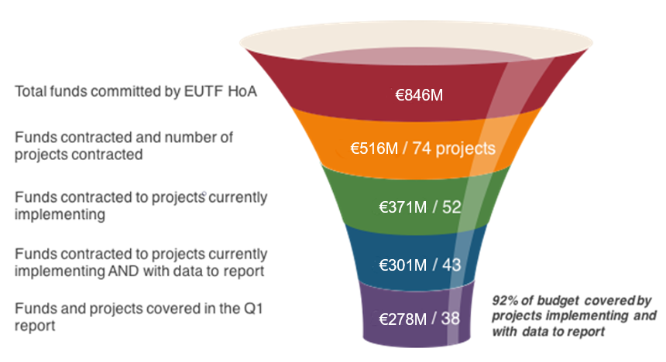
Table 1: EUTF HoA projects implementing and with data to report
Country | Programme Name | EUTF ID | Project Name | Lead IP | Budget EUTF
Regional | Better Migration Management Programme | T05-EUTF-HOA-REG-09-01 | Better Migration Management (BMM) | GIZ | € 40,000,000
Regional | Strengthening the ability of IGAD to promote resilience in the Horn of Africa | T05-EUTF-HOA-REG-20-02 | Strengthening the ability of IGAD to promote resilience in the Horn of Africa - Direct Grant to IGAD | IGAD | € 1,400,000
Regional |  | T05-EUTF-HOA-REG-20-01 | Strengthening the ability of IGAD to promote resilience in the Horn of Africa - Delegation Ag. to GIZ | GIZ | € 2,100,000
Regional | Monitoring and Learning System for the EUTF Horn of Africa (MLS) | T05-EUTF-HOA-REG-28-01 | Monitoring and Learning System for the EUTF Horn of Africa | Altai | € 1,949,000
Regional | Research and Evidence Facility (REF) | T05-EUTF-HOA-REG-10-01 | Research and Evidence Facility | SOAS | € 3,995,357
Regional | Facility on Sustainable and Dignified Return and Reintegration in support of the Khartoum Process | T05-EUTF-HOA-REG-25-01 | Facility on Sustainable and Dignified Return and Reintegration | IOM | € 25,000,000
Ethiopia | Regional Development and Protection Programme (RDPP) | T05-EUTF-HOA-ET-15-04 | RDPP in Ethiopia-Bahrale and Aysaita Areas | DCA | € 4,000,000
Ethiopia | Regional Development and Protection Programme (RDPP) | T05-EUTF-HOA-ET-15-01 | RDPP in Ethiopia-Shire Area | IRC | € 8,500,000
Ethiopia | Regional Development and Protection Programme (RDPP) | T05-EUTF-HOA-ET-15-02 | RDPP in Ethiopia-Dollo Ado Area | NRC | € 8,000,000
Ethiopia | Regional Development and Protection Programme (RDPP) | T05-EUTF-HOA-ET-15-05 | RDPP in Ethiopia in Urban Areas of Addis Ababa and Shire | Plan | € 3,500,000
Ethiopia | Regional Development and Protection Programme (RDPP) | T05-EUTF-HOA-ET-15-03 | RDPP in Ethiopia-Jijiga Area | SC | € 5,300,000
Ethiopia | Resilience Building and Creation of Economic Opportunities in Ethiopia (RESET II) | T05-EUTF-HOA-ET-01-01 | Integrated multi-sector approach to improve the resilience of vulnerable communities in Wag Himra Zone, Amhara region, Ethiopia | ACF | € 6,000,000
Ethiopia |  | T05-EUTF-HOA-ET-01-04 | Promoting Resilient Livelihoods in Borana | CARE | € 5,940,000
Ethiopia |  | T05-EUTF-HOA-ET-01-03 | Building resilience and creation of economic opportunities in Liben cluster under RESET II | Cordaid | € 4,252,073 (not in report)
Ethiopia |  | T05-EUTF-HOA-ET-01-05 | Increasing Resilience and Economic Opportunities in Drought Prone Areas of Bale Zone | DCA | € 5,500,000 (not in report)
Ethiopia |  | T05-EUTF-HOA-ET-01-08 | Resilience Building and Creation of Economic Opportunities in Ethiopia (Oxfam) | Oxfam | € 5,580,000
Ethiopia |  | T05-EUTF-HOA-ET-01-02 | Resilient Economy and Livelihoods (REAL) | iDE | € 4,949,244
Ethiopia |  | T05-EUTF-HOA-ET-01-07 | Improving Livelihoods and Building Resilience in Afar Regional Sate | SC | € 7,000,000
Ethiopia |  | T05-EUTF-HOA-ET-01-06 | Resilience Building for Sustainable Livelihoods & Transformation (RESULT) in South Omo cluster, SNNPR | Vita | € 4,230,000 (not in report)
Kenya | RDPP in Kenya: Support to the Kalobeyei Development Programme | T05-EUTF-HOA-KE-17-01 | RDPP in Kenya: Support to the Kalobeyei Development Programme | UNHCR | € 14,700,000
Kenya | Conflict prevention, peace and economic opportunities for the youth | T05-EUTF-HOA-KE-18-02 | Conflict Prevention, peace, and economic opportunities for the youth | GIZ | € 2,920,000
Kenya |  | T05-EUTF-HOA-KE-18-03 | Conflict prevention, peace, and economic opportunities for the youth | KRCS | € 5,920,000
Kenya |  | T05-EUTF-HOA-KE-18-01 | Strengthening Resilience to Violent Extremism II - STRIVE II | RUSI | € 2,920,000
Kenya |  | T05-EUTF-HOA-KE-18-04 | Conflict prevention, peace and economic opportunities for the youth | SAIDC | € 1,900,000
Sudan | Mitigate the effect of El Nino for the host and IDP population in Red Sea, White Nile and North Darfur, Sudan | T05-EUTF-HOA-SD-22-02 | Mitigate the effect of El Nino in White Nile State (ADRA) | ADRA | € 3,750,000
Sudan | RDPP in Sudan: Enhancing alternatives to first and secondary movement from Sudan | T05-EUTF-HOA-SD-11-03 | RDPP in Sudan: Enhancing alternatives to first and secondary movement from Sudan (GIZ) | GIZ | € 4,000,000
Somalia | Enhancing Somalia's responsiveness to the management and reintegration of mixed migration flows (RE-INTEG) | T05-EUTF-HOA-SO-03-04 | Durable Solutions for IDPs and Returnees in Somalia (DSIRS) | CARE | € 9,000,000 (not in report)
Somalia |  | T05-EUTF-HOA-SO-03-07 | Enhancing Integration of Displacement Affected Communities in Somalia (EIDACS) | CW | € 4,000,000
Somalia |  | T05-EUTF-HOA-SO-03-10 | Enhancing integration of displacement-affected communities in Somalia - Baidoa (EIDACS-B, Concern) | CW | € 1,000,000
Somalia |  | T05-EUTF-HOA-SO-03-09 | Supporting the development and implementation of policies for the return, reintegration and protection of IDPs and refugees (IDLO) | IDLO | € 2,967,280
Somalia |  | T05-EUTF-HOA-SO-03-02 | Facilitating Sustainable Return Through Laying Foundations for Somalia in the Horn of Africa | IOM | € 5,000,000
Somalia |  | T05-EUTF-HOA-SO-03-08 | Durable Solutions and Reintegration Support to Displacement affected communities in Jubbaland state of Somalia | NRC | € 4,000,000
Somalia |  | T05-EUTF-HOA-SO-03-06 | Innovative durable solutions for IDPs and returnees in Mogadishu through enhanced governance, employment and access to basic and protective services | UN-Habitat | € 12,000,000
Somalia |  | T05-EUTF-HOA-SO-03-03 | Enhancing Somalia's responsiveness to the management and reintegration of mixed migration flows (UNHCR) | UNHCR | € 5,000,000
Somalia |  | T05-EUTF-HOA-SO-03-05 | Wadajir - Enhancing durable solutions for and reintegration of displacement affected communities in Somaliland | World Vision | € 4,000,000
South Sudan | Support to stabilisation through improved resource, economic and financial management in South Sudan | T05-EUTF-HOA-SS-05-01 | Technical Assistance for Sub-National Capacity Building in Payroll and PFM: Extension and Bridging Phase | Ecorys | € 999,924
South Sudan | Health Pooled Fund II (HPFII) | T05-EUTF-HOA-SS-04-01 | Health Pooled Fund II (HPFII) | DFID | € 20,000,000
South Sudan | IMPACT South Sudan | T05-EUTF-HOA-SS-06-01 | IMPACT South Sudan | Mott MacDonald | € 25,993,000
Uganda | Regional Development and Protection Programme (RDPP): Support Programme to the Refugee Settlements and Host Communities in Northern Uganda (SPRS-NU) | T05-EUTF-HOA-UG-07-03 | RDPP Support Programme to the Refugee Settlements and Host Communities in Northern Uganda (SPRS-NU) - WASH component led by ADA | ADA | € 4,900,000
Uganda |  | T05-EUTF-HOA-UG-07-02 | RDPP Support Programme to the Refugee Settlements and Host Communities in Northern Uganda (SPRS-NU) - NGO Consortium | DRC | € 10,000,000
Uganda |  | T05-EUTF-HOA-UG-07-01 | RDPP Support Programme to the Refugee Settlements and Host Communities in Northern Uganda (SPRS-NU) - Enabel | Enabel/BTC | € 4,900,000
Uganda | Strengthening Social Cohesion and Stability in Slum Populations | T05-EUTF-HOA-UG-08-01 | Strengthening Social Cohesion and Stability in Slum Populations | IOM | € 4,300,000
Figure 6: All signed EUTF HOA contracts by budget and status of implementation (74 projects – includes projects in inception and in early phases of implementation as well as 43 projects with data)
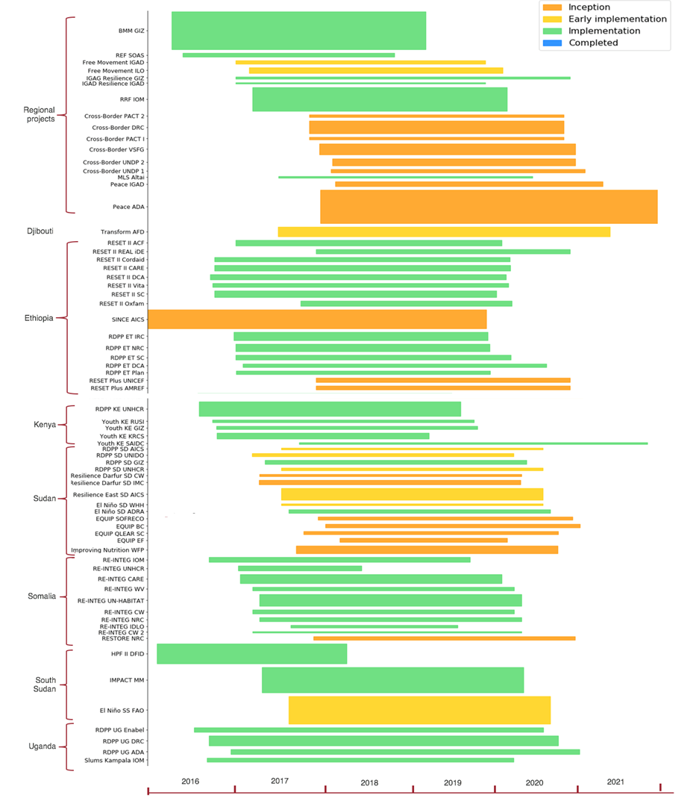

Overview by Strategic objective and EUTF common output indicator
Overall, the two top strategic objectives (SOs) in terms of funds allocated are SO2 ‘Strengthening resilience’ with 38% of the contracted funds, followed by SO1 ‘Greater economic and employment opportunities’ with 29%. SO4 ‘Improved governance’ is third with 18%, followed lastly by SO3 ‘Improving migration management’ at 12%.
Figure 7: Breakdown of contracted budget by country and strategic objective, May 2018
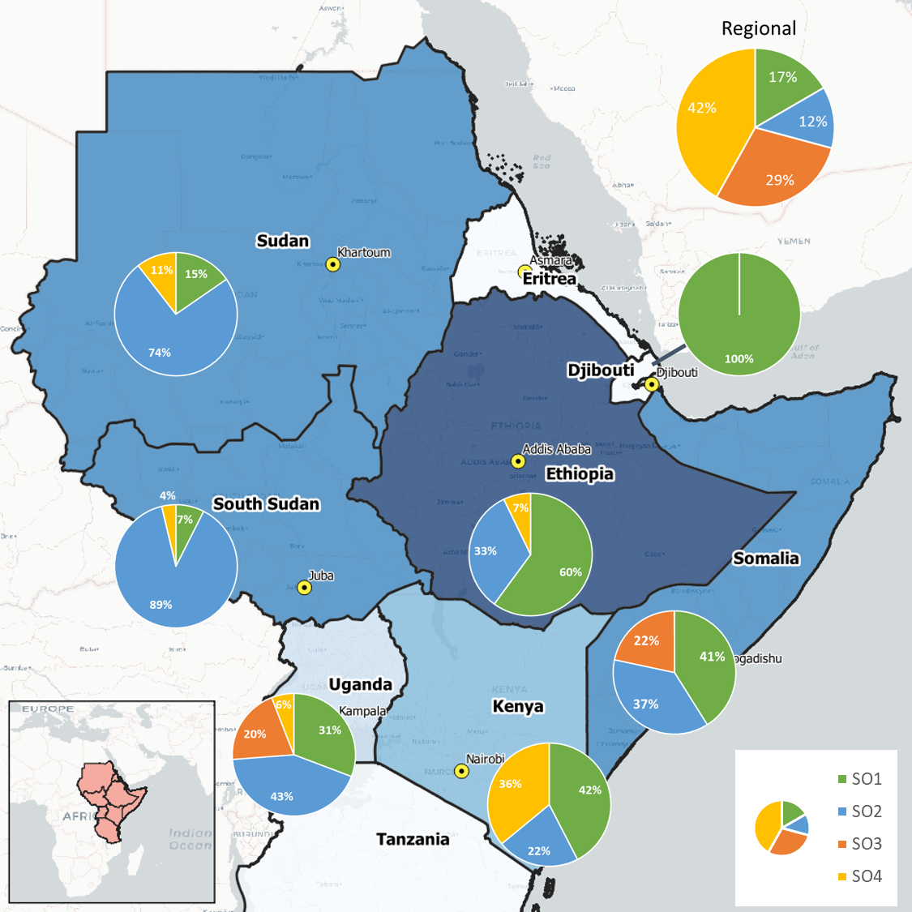

As discussed in the methodology section, an initial list of 19 EUTF common output indicators was developed, refined and disaggregated to become a list of 41 indicators used across the 3 windows of the EUTF and divided according to the 4 above-mentioned strategic objectives.
Data gathered from the 38 projects in Q1 and mapped against the 41 indicators suggest the following results in terms of targets and numbers achieved so far for the HoA window. It is worth emphasising that because these indicators aim to provide a common monitoring framework for the three windows to track key outputs, and not to reflect the entire breadth of EUTF-funded projects in the HoA, many of the projects included in this report are achieving far more than can be expressed through the EUTF common output indicators.
Table 2: Targets and results achieved so far by EUTF common output indicator, March 2018
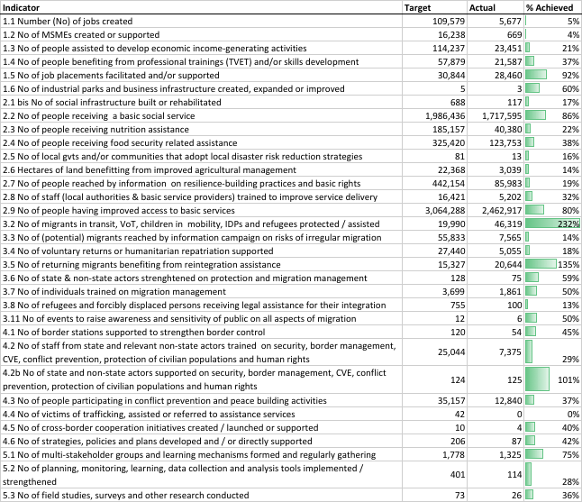
On average, progress made against targets in the HoA region very much depends on the nature of the activity developed, from a very slow progress rate for activities requiring several phases of programming before proper structures are put in place and outputs are generated (e.g. victims of trafficking assisted), to activities like the provision of basic services where targets were already surpassed for some EUTF common output indicators.
With regards to indicators where actual achievements far surpass targets, it should be noted that they include a variety of situations: cases where targets were low and were indeed surpassed, but also cases in which IPs could not provide targets for the indicators (especially in cases where their M&E systems were already fully set up). As the MLS’s work continues, targets are thus likely to change and particular emphasis will be placed on developing targets wherever possible and currently inexistent.
Across countries, programmes are aligned with the EUTF common output indicators to different degrees, with some programmes having more of a broad nature and therefore covering several major common output indicators and reflecting more than one strategic objective (examples include RESET II, some of the RDPPs and RE-INTEG which, in addition to being broad, has 8 projects covered in this report), and other programmes being more focused in nature and covering fewer indicators as well as fewer strategic objectives (such as, HPFII, which focuses on health, IMPACT, which deals only with education, etc). RDPP Sudan is an unusual example of having fewer indicators, as current data covers only one of the project components, which focuses mainly on training and employment opportunities for beneficiaries (the five other projects are either not contracted or have only just begun implementing).
Figure 8: Scoring of programmes by number of EUTF common output indicators, as of March 2018
Conversely, in the below chart, one can see how many programmes inform each indicator. In this regard, EUTF indicator 1.3 ‘People assisted to develop economic income generating activities (IGA)’ is informed by 25 programmes, making it a very popular activity. It is followed by EUTF indicator 1.1 ‘Jobs created’, EUTF indicator 2.2 ‘People receiving a basic service’, EUTF indicator 1.4 ‘Number of people benefiting from professional trainings – TVET – and/or skills development’ and EUTF indicator 2.8 ‘Number of staff from local authorities and basic service providers benefiting from capacity building for strengthening service delivery’.
Figure 9: EUTF common output indicators by number of programmes that inform each indicator, as of March 2018
More detailed analysis by strategic objective and for some key common output indicators can be found in 3.4 Analysis by Strategic Objective.

Overview by Implementing partner
Figure 10: Breakdown of contracted funds by type of implementing partner, May 2018
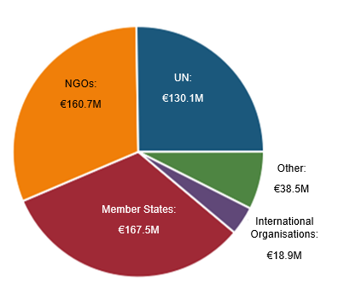
So far, contracts have been signed with 48 IPs (including 29 in the Q1 report), the largest of which (in terms of total funds contracted) is GIZ (€49M overall, largely due to BMM with €40M), followed by IOM (with €34.3M overall) and Mott MacDonald (close to €26M for the IMPACT programme in South Sudan).

Analysis by country
The following analysis has been divided in two main parts: first by country (including a first part on the regional programmes) and second by strategic objectives.

Regional programmes
A total of 6 regional programmes and projects are included in this report. Analysis in this section will concentrate on the Better Migration Management programme, the IGAD resilience programme (divided into 2 contracts, one with IGAD and the other with GIZ) and the Regional Reintegration Facility. The MLS and REF will be treated in the report’s Annex along with the specific projects.
In addition to these, the special position of the Regional Development and Protection Programme (RDPP) should be highlighted: while it is not considered a regional programme or a Decision per se at the EU level, but rather as a group of national programmes, it is nevertheless designed and led in a regional fashion and has its own evaluation component (LET).

Better migration management
The Horn of Africa region is at the centre of three migratory routes, and hosts more than 5.2 million refugees and asylum seekers and 5.8 million IDPs. In this context, the Better Migration Management programme aims to improve migration management in the Horn of Africa, with a specific focus on trafficking and smuggling of migrants along migratory routes. The project is implemented by a consortium that is led by GIZ and includes the British Council, Civipol, Expertise France, IOM, UNODC, and the Italian Department of Public Security as an associated partner. Because the issue the programme seeks to address is a regional one, it is active in all countries of the Horn and relies on collaboration with the Khartoum Process, a platform for political cooperation and dialogue between the countries along the migration route between the Horn of Africa and Europe.
The programme aims to enhance cooperation between the countries in the region and to support the harmonisation of policies and laws that improve migration management. It supports the institutions and agencies responsible for migration management through capacity building. BMM also aims to enhance the protection and the safety of migrants on the road through reinforcement of the personnel in charge of identification and referral of vulnerable migrants, and of the structures that provide services to migrants in transit and victims of trafficking. Finally, the programme intends to raise awareness among migrants, potential migrants and the general population of alternative livelihood options.
Table 3: BMM – Key facts and figures
Key facts and figures
Full programme name | Better Migration Management
Short programme name | BMM
Location(s) of implementation | Djibouti, Ethiopia, Eritrea, Kenya, Somalia, South Sudan, Sudan, Uganda – (Egypt and Tunisia)
Total budget | €46,000,000 (includes €6M co-funding from BMZ)
Total EUTF budget committed | €40,000,000
Date at which EUTF budget was committed | 16 Dec 2015
Budget contracted so far | €40,000,000
Number of projects | 1
Main IP(s) | GIZ, leading a consortium composed by British Council, Civipol, Expertise France, IOM, UNODC and the Italian Department of public security as an associated partner
Target beneficiaries | Migrants and victims of trafficking and smuggling in the target countries
Start date | April 2016
End date | March 2019
Number of projects in report | 1

Table 4: BMM – Key indicators (results achieved as of March 2018)
3.2 No of migrants in transit, victims of human trafficking, children in the mobility, IDPs and refugees protected or assisted. | 7,340
3.3 No of migrants, or potential migrants, reached by information campaign on migration and risks linked to irregular migration | 6,425
3.7 No of individuals trained on migration management | 1,626
4.2 No of staff from governmental institutions, internal security forces and relevant non-state actors trained on security, border management, CVE, conflict prevention, protection of civilian populations and human rights | 575
3.4 No of voluntary returns or humanitarian repatriation supported | 282

Facility on sustainable and dignified return and reintegration in support of the Khartoum process
The ‘Facility on Sustainable and Dignified Return and Reintegration in support of the Khartoum Process’ or Regional Reintegration Facility (RRF) is implemented by the International Organization for Migration (IOM) in 4 country members of the Khartoum Process.
It aims at supporting the development of sustainable return and reintegration policies by i) building the capacity of governments and relevant stakeholders to develop return and reintegration policies and processes, ii) facilitating Assisted Voluntary Return and Reintegration (AVRR) processes – with 3,800 migrants in transit assisted and protected – and ii) facilitating the reintegration of returnees (with a target of 4,200 individuals assisted to develop income-generating activities).
Table 5: RRF – Key facts and figures
Key facts and figures
Full programme name | Facility on Sustainable and Dignified Return and Reintegration in support of the Khartoum Process
Short programme name | Regional Reintegration Facility (RRF)
Location(s) of implementation | Djibouti, Ethiopia, Somalia, Sudan
Total budget | €25,000,000
Total EUTF budget committed | €25,000,000
Date at which EUTF budget was committed | December 2016
Budget contracted so far | €25,000,000
Number of projects | 1
Main IP(s) | IOM
Target beneficiaries | Returnees and migrants in transit
Start date | March 2017
End date | March 2020
Number of projects in report | 1
Table 6: RRF – Key indicators (results achieved as of March 2018)
3.2 No of migrants in transit, victims of human trafficking, children in the mobility, IDPs and refugees protected or assisted. | 2,009
3.4 No of voluntary returns or humanitarian repatriation supported | 818
3.5 No of returning migrants benefiting from reintegration assistance | 221
1.3 No of people assisted to develop economic income-generating activities | 172
3.7 No of individuals trained on migration management | 75

Strengthening the ability of IGAD to promote resilience in the Horn of Africa
The ‘Strengthening the ability of IGAD to promote resilience in the Horn of Africa’ programme is one of three programmes funded by the EUTF working with the HoA-based regional Intergovernmental Authority for Development (IGAD). Its objective is to ‘strengthen IGAD’s capacity for coordinating and facilitating the implementation of IDDRSI to build resilience’ under Strategic Objective 4 (Improved governance and conflict prevention) and, by extension, to ‘make the IGAD region more resilient’ under Strategic Objective 2 (Strengthening resilience of communities). The programme is divided into two projects, one awarded to IGAD itself and the other implemented by GIZ.
Table 7: IGAD Resilience – Key facts and figures
Key facts and figures
Full programme name | Strengthening the ability of IGAD to promote resilience in the Horn of Africa
Short programme name | IGAD Resilience
Location(s) of implementation | Regional
Total budget | €7,000,000 (includes €2M co-funding from BMZ)
Total EUTF budget committed | €5,000,000
Date at which EUTF budget was committed | April 2016
Budget contracted so far | €3,500,000
Number of projects | 2
Main IP(s) | IGAD, GIZ
Target beneficiaries | IGAD, ASAL communities in the IGAD region
Number of projects in report | 2
Table 8: IGAD Resilience – Key indicators (results achieved as of March 2018)
3.6 No of state and non-state actors directly strengthened through capacity building or operational support on migration management | 8
3.7 No of individuals trained on migration management | 15
4.6 No of strategies, policies and plans developed and / or directly supported | 2
4.5 No of cross-border cooperation initiatives created, launched or supported | 1

Focus box 1: Introduction to the IGAD case study: focus on EUTF projects and institution building
The MLS is conducting a longitudinal case study on IGAD and the support it receives from donors, with a focus on EUTF funding. The objective is to investigate how these different contributions help the regional organisation to fulfil its mandate, and / or support the organisation’s institutional strengthening. It will also explore the way institutional development can be measured with time.
Contextual analysis: The case study first provides a comprehensive contextual analysis of the organisation’s strengths and weaknesses. IGAD’s significant expansion over the past decade largely reinforced its legitimacy to implement regional programmes, but also led to structural challenges.
Its convening power and capacity to bring regional countries together is key when implementing programmes tackling cross-country challenges such as resilience, climate change, natural resource management, and labour mobility and migration flows. However, structural challenges, including a very horizontal organisational structure, combined with limited communication across the organisation, can also hinder implementation. This has also led some divisions and specialised institutions within IGAD to function in silos, developing their own human resources, administration and finance, resource mobilisation, and / or M&E systems. IGAD’s funding mechanism also makes the organisation heavily reliant on external donors as opposed to member state contributions, weakening its capacity to centrally define its strategy.
EUTF support and other donor programmes: Within the context of this wider organisational analysis, the MLS will conduct a donor mapping of current financial support, to show who supports which programmes, under which IGAD strategic pillar, and the extent to which these programmes focus on implementation or on institution building. The team will then further explore the EUTF-funded programmes, namely:
- Towards Free Movement of Persons and Transhumance in the IGAD region;
- Strengthening the ability of IGAD to promote resilience in the HoA;
- Promoting Peace and Stability in the HoA Region and;
- Collaboration in Cross-Border Areas of the HoA Region.
The last two, which are still in inception phase, will only be included in the next round of this case study (2019).
Best practices through a longitudinal approach: The learning team will analyse the specificities of the projects’ approaches and identify best practices in terms of institutional development. The case study will be revisited every 9 to 12 months to measure any changes (longitudinal approach). This will allow the learning team to monitor progress made in terms of achieving strategic objectives and institutional strengthening, and the way projects build on lessons learned over time.

Regional Development and Protection Programme
As discussed above, the RDPP is not considered a regional programme per se but is included in this section because of its inherent regional nature.
Focus box 2: The EU Regional Development and Protection Programme (RDPP)
The EU Regional Development and Protection Programme (RDPP) in the Horn of Africa, led by the Netherlands, has been set up to improve protection and enhance the development prospects of refugees, IDPs and local communities by offering an alternative to the risks of irregular migration. It aims to improve prospects for refugees as well as host communities, with a view to enabling beneficiaries to be able to provide for their own livelihood, as well as to improving social cohesion by implementing activities that include and benefit both refugees and their neighbouring host communities. Ethiopia, Sudan, Kenya and Uganda are key countries for the RDPP as they all host large numbers of refugees.
Thus far, the RDPP has directly provided basic services to 96,866 people, of whom 26% are part of the host communities and 74% refugees, with host communities primarily benefiting from domestic energy services and refugees principally accessing health and education services. More equitably, 53% of 15,166 people assisted to develop income-generating activities are refugees and 43% are host community members. It is worth highlighting that, while 65% of IGA beneficiaries are women, the same is true for only 33% of permanent jobs and 32% of cash for work jobs created by RDPP.
Figure 11: EUTF RDPP funding by country
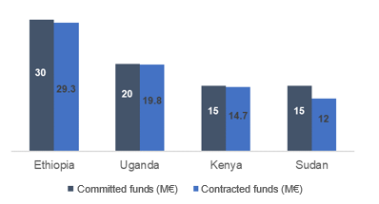
Table 9: RDPP – Key indicators (results achieved as of March 2018)

2.2 No of people receiving a basic social service | 96,886
2.9 No of people having improved access to basic services | 91,986
1.4 No of people benefiting from professional trainings (TVET) and/or skills development | 20,449
1.3 No of people assisted to develop economic income-generating activities | 15,116
1.1 No of jobs created | 3,788

Ethiopia

Ethiopia’s migration profile
Figure 12: Key programmes and migration flows in Ethiopia, May 2018
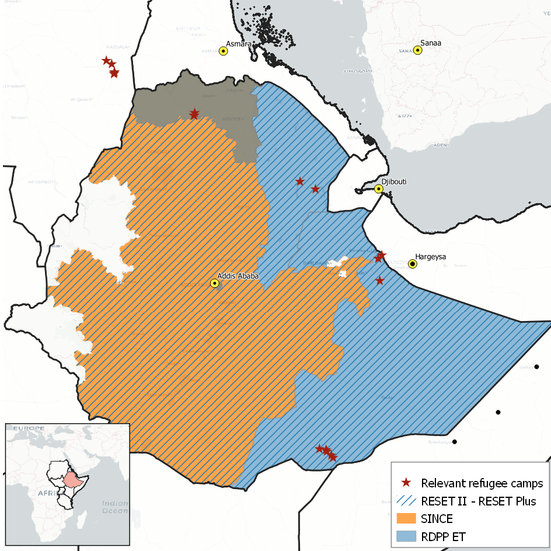

Ethiopia’s migration profile has been shaped on the one hand by its status as host to one of the largest refugee populations in Africa, and on the other by its high emigration rate, usually for economic reasons and often through irregular channels. The EUTF has sought to address both of these dynamics as part of its implementation strategy in the country, with most of its disbursed funding for Ethiopia directed towards Strategic Objective 1 (Greater economic and employment opportunities) and Strategic Objective 2 (Strengthening resilience of communities).
With over 916,678 refugees and asylum seekers registered as of March 2018, Ethiopia hosts among the largest refugee populations in Africa. This is in part due to its proximity to conflicts in neighbouring countries such as South Sudan and Somalia, but also because it maintains an ‘open door’ policy that grants asylum on a prima facie basis, such that asylum seekers are presumed to be fleeing life-threatening circumstances unless and until proven otherwise. In 2016, the government pledged a number of measures in line with the global CRRF in order to facilitate the integration of refugees into local communities. Since then, it has conducted large-scale school enrolment campaigns, granted government scholarships to more than 2,000 refugees to undertake tertiary studies, and passed legislation to include refugees in the national civil registration system, allowing them to obtain legal documents and thus access a number of critical social services for the first time. ‘Supporting Ethiopia in its hospitality for refugees from neighbouring countries’ is therefore a ‘priority action’ for the EUTF, as illustrated by its funding of RDPP projects in the Addis Ababa, Afar, Somali and Tigray Regions.
On the other hand, and although there are no official statistics available, it is thought that large numbers of Ethiopians leave the country every year in search of employment in the Middle East, Europe and South Africa. It is likely that youths comprise a large proportion of these numbers, with 3 million young Ethiopians joining the national labour force every year, ‘high demographic growth outnumbering levels of job creation’, and a notable shortage of opportunities for educated, qualified youths. As such, addressing youth employment is a key focus of the EUTF’s strategy in Ethiopia, with programmes such as RESET II explicitly targeting youths for income-generating activities, cooperatives, business training, and TVET.
Ethiopia programmes not reported on herewith due to being in inception phase or not yet contracted include: RESET PLUS, designed to complement gaps in the RESET II programme; three programmes aimed at stimulating employment creation (SINCE, LISEC, and CRRF ET); Shire Alliance, which aims to improve sustainable energy access for refugee and host communities; and a direct grant to the Ethiopian Administration for Refugees and Returnees Affairs (ARRA) to support the sustainable reintegration of Ethiopian returnees.

Table 10: Ethiopia – Key facts and figures
Overall migration data
Total population | 102,400,000
Number of refugees in the country | Over 916,678
Refugees as % of total population | 0.9%
Emigrants who left the country | 800,900
Top 3 migrant groups by country of origin | Somalia, South Sudan, Eritrea
HDI Ranking [1 = High - 188 = Low] | 174
EUTF data as of May 2018
Total funds committed so far | €174,007,000
Total funds contracted so far | €101,498,541
Number of programmes with committed funds | 8
Number of projects contracted so far | 18
Q1 report data
Number of projects in report | 10
Number of indicators reported against SO1 | 5
Number of indicators reported against SO2 | 9
Number of indicators reported against SO3 | 5
Number of indicators reported against SO4 | 5
Number of cross-cutting indicators reported | 2

Ethiopia and the EUTF common output indicators
Table 11: Ethiopia – Key indicators (results achieved as of March 2018)
2.9 No of people having improved access to basic services | 1,009,613
2.4 No of people receiving food security related assistance | 113,837
2.7 No of people reached by information campaigns on resilience-building practices and basic rights | 40,202
2.2 No of people receiving a basic social service | 36,183
1.3 No of people assisted to develop income generating activities (IGAs) | 5,605

RDPP and RESET II’s strong focus on access to basic services and income generation are illustrated in the graphs below. RESET II partners have thus far constructed or rehabilitated a large number of water points or systems, as poor rural areas in Ethiopia are highly prone to water shortages and poor sanitation, whereas RDPP partners have focused more on energy access, which is generally extremely low in Ethiopia and particularly so in the remote locations that host refugee camps.
It is worth noting that the large number of host community beneficiaries illustrated below is chiefly attributable to the 15,600 beneficiaries benefiting from energy services (household solar kits, street lighting systems and fuel-efficient cook stoves) provided by NRC in RDPP.
Figure 13: Number of people receiving a basic social service (EUTF indicator 2.2) in Ethiopia by type of beneficiary
Figure 14: Number of social infrastructure built or rehabilitated (EUTF indicator 2.1 bis) in Ethiopia by type of infrastructure
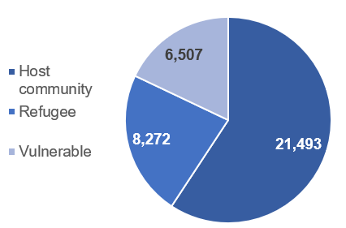 | 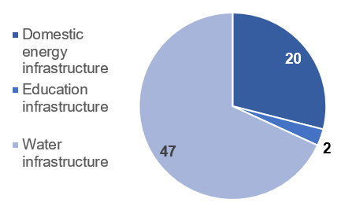
Figure 15: Number of people receiving a basic social service (EUTF indicator 2.2) in Ethiopia by type of service
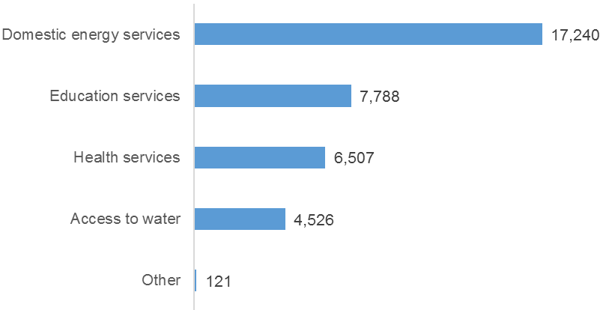

Women have thus far benefited significantly more than men from job creation, mainly due to the emphasis that both programmes place on women for income-generating activities in an effort to support the most vulnerable. However, it may be worth noting that far more men have benefited from the small number of formal, long-term employment opportunities created so far than women.
Figure 16: Number of jobs created (EUTF indicator 1.1) in Ethiopia, by gender and type of job

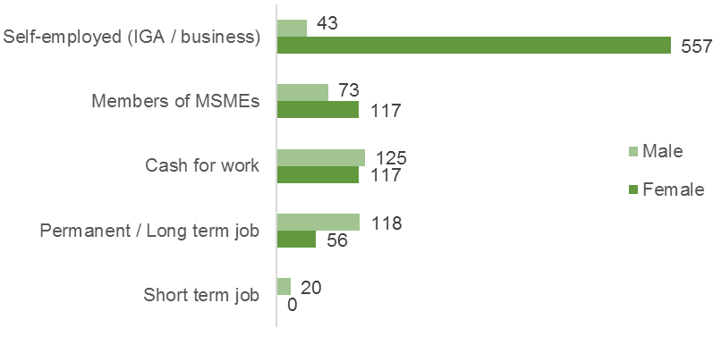

Finally, it is worth highlighting that two Ethiopia IPs (NRC from RDPP and iDE UK from RESET II) have conducted awareness-raising campaigns on the risks of irregular migration, reaching a combined total of 1,132 people.

Ethiopia – Regional Development and Protection Programme
The Regional Development and Protection Programme (RDPP) in Ethiopia aims to provide sustainable development and protection solutions for refugees and their host communities in Ethiopia, thereby providing alternatives to irregular primary and secondary movements. Approved in 2016, the programme intends to benefit 100,000 to 120,000 Eritrean and Somali refugees living both in and out of camp, as well as host communities in the surrounding areas.
RDPP is implemented in the Afar, Tigray and Somali Regions of Ethiopia, as well as the cities of Shire and Addis Ababa, as these areas host most of the country’s Eritrean and Somali refugees. With a €30M budget in Ethiopia, RDPP aims to improve access to integrated basic services (water, energy and education) and to promote livelihood opportunities (including through vocational training and market research) for both refugees and their surrounding host communities in an effort to improve social cohesion and conflict prevention. These core programme components are complemented by a pilot project to enhance protection and access to justice (particularly for vulnerable groups such as women), and by activities to strengthen the capacity of local authorities and multi-stakeholder coordination platforms to implement a coordinated refugee response.
Table 12: RDPP ET – Key facts and figures
Key facts and figures
Full programme name | Regional Development and Protection Programme
Short programme name | RDPP ET
Location(s) of implementation | Afar, Addis Ababa, Tigray, Somali
Total budget | €30,000,000
Total EUTF budget committed | €30,000,000
Date at which EUTF budget was committed | April 2016
Budget contracted so far | €29,300,000
Number of projects | 5
Main IP(s) | DCA, IRC, NRC, Plan, SC
Target beneficiaries | Eritrean and Somali refugees in and out of camp, and their neighbouring host communities
Number of projects in report | 5

Table 13: RDPP ET – Key indicators (results achieved as of March 2018)
2.9 No of people having improved access to basic services | 41,497
2.2 No of people receiving a basic social service | 29,675
2.7 No of people reached by information campaigns on resilience-building practices and basic rights | 24,857
1.3 No of people assisted to develop economic income-generating activities | 1,619
1.4 No of people benefiting from professional trainings (TVET) and / or skills development | 1,083

Ethiopia – Resilience Building and Creation of Economic Opportunities in Ethiopia
Prior to the EUTF, the EU was funding multiple similar but separate resilience-building projects in Ethiopia known collectively as RESET (now referred to as RESET I). In 2016, the ‘Resilience Building and Creation of Economic Opportunities in Ethiopia II’ or RESET II was launched as a single programme funded by the EUTF, in the same geographical areas as RESET I and often with the same implementing partners, with an estimated 1.2 million direct beneficiaries. RESET II is implemented in the eight 'EU Resilience Clusters', which are geographical areas comprised of groups of adjacent woredas (districts) selected based on their vulnerability.
Through RESET II, the EUTF aims to address the root causes of Ethiopian migration from rural areas by: i) improving the provision of basic services (health, nutrition and WASH); ii) supporting livelihoods (notably by increasing livestock and crop productivity) and promoting livelihood diversification; iii) strengthening natural resource management and disaster risk reduction; and iv) enhanced research and knowledge management. Moreover, the RESET II partners conduct awareness-raising events on the dynamics, drivers and causes of instability and forced displacement, as well as on the risks of irregular migration, in an effort to address and mitigate these trends.
RESET II case study: A case study was dedicated to RESET II as a part of the MLS Learning Component, as briefly introduced in section 2.4 above. A 2-pager summary is available in the Annex of this report and a full case study report highlighting best practices and lessons learned from RESET II in the Wolaita cluster will be shared with EUTF stakeholders in June 2018.

Table 14: RESET II – Key facts and figures
Key facts and figures
Full programme name | Resilience Building and Creation of Economic Opportunities in Ethiopia
Short programme name | RESET II
Location(s) of implementation | Afar, Amhara, Oromia, Somali and SNNP Regions
Total budget | €48,362,000
Total EUTF budget committed | €48,362,000
Date at which EUTF budget was committed | December 2015
Budget contracted so far | €43,451,317
Number of projects | 8
Main IP(s) | ACF, CARE, CORDAID, DCA, iDE, Oxfam, SC, VITA
Target beneficiaries | Vulnerable rural communities in areas prone to migration
Number of projects in report | 5

Table 15: RESET II – Key indicators (results achieved as of March 2018)
2.9 No of people having improved access to basic services | 968,116
2.4 No of people receiving food security related assistance | 113,137
2.2 No of people receiving a basic social service | 6,508
1.1 No of jobs created | 840
2.1bis No of social infrastructure built or rehabilitated | 44

Focus box 3: RESET II Specificities
RESET II is a unique programme in the EUTF HoA portfolio. Of the programmes included in this report, RESET II has contributed to 39% of the people benefiting from improved access to services, and to 99.8% of the 3,038 hectares of rehabilitated agricultural land. It is also thus far the only programme reporting against EUTF indicator 2.5 (Number of local governments and/or communities that adopt and implement local disaster risk reduction strategies), thanks to a dedicated DRR component in all RESET II projects.

Focus box 4: Key findings from RESET II Case study: an integrated approach to resilience building
Background and objectives: The RESET II / Wolaita Cluster case study focuses on one of the projects within the RESET II programme, which aims to build resilience in eight drought-prone rural areas of Ethiopia (called ‘clusters’). RESET II activities in the Wolaita cluster are implemented under the acronym ‘REAL’ and reach over 25,000 households in the cluster. This case study highlights best practices identified in the context of the project’s organisation and approach, and provides insights on the link between resilience and migration.
A combination of best practices: Our research found the REAL project’s organisation and approach to be in line with best practices in resilience-building identified by the EU in Ethiopia: the close integration of consortium partners optimises resources and expertise; the integration of the government and private partners builds the sustainability of the project; integrated services diversify household livelihood options and strengthen resilience, with each beneficiary household receiving at least two and up to four interventions (see diagram below); and well-sequenced activities and continuous engagement with stakeholders strengthen the adaptive capacity of communities in a sustainable manner.
Figure 17: REAL’s contributions to the four pillars of the EU ‘basic resilience model’ in Ethiopia
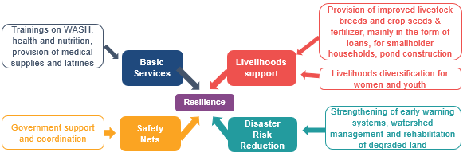

Resilience and migration – initial evidence of impact and further evaluations to be conducted: Initial qualitative assessments indicate that the provision of basic services and improvements in farming productivity can lift some households out of poverty and thereby decrease the number of children forced to drop out of school and migrate to cities. The job creation aspect of the project also prevents some youth from migrating and encourages others to return. However, broader structural changes beyond the project scope will be necessary to significantly impact youth employment. More rigorously measuring the impact of the project on resilience and migration remains a challenge, and more robust impact evaluations are likely to be needed in the future.

South Sudan

South Sudan’s migration profile
Figure 18: Key programmes and migration flows in South Sudan, May 2018
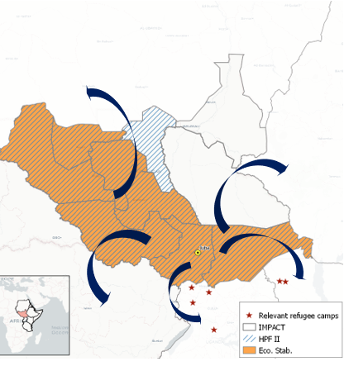
The conflict in South Sudan and its impact on neighbouring countries has quickly escalated into a full-blown humanitarian emergency. Most of the resultant refugees are women and children (those under 18 years of age account for 63% of South Sudanese refugees), many of whom flee across the border alone, often arriving at their destination weak and malnourished. During the rainy season, needs are compounded by flooding, food shortages and disease. An outbreak of violence in South Sudan in July 2016 reignited conflict throughout the country, aggravating a dire humanitarian situation, and provoking a massive displacement of people.
In South Sudan, nearly two million people are displaced internally (1.8 million IDPs according to the UNHCR in February 2018), while outside the country there are now almost two and a half million South Sudanese refugees, mainly in Ethiopia, Sudan, and Uganda, with UNHCR expecting the number to grow to as many as 3.1 million by December 2018. Many of these refugees fear imminent attack or struggle with food insecurity. Over 40% of all South Sudanese refugees are settled in Uganda, which has taken in more than one million, mostly in the northern part of the country. Sudan is the second biggest host of South Sudanese, with some 763,000 individuals currently in the country.
The EUTF’s funding in South Sudan focuses on strengthening the resilience of its most vulnerable people, many of whom find themselves suffering from the conflict situation as well as the effects of climate change, the combination of which has led to an alarming food security crisis. In particular, the EUTF is focusing on key sectors like health, by contributing to the large Health Pooled Fund II (HPF II) programme which focuses on improving maternal and child health; education, by financing incentives for teachers to return to their schools through the IMPACT programme; and food security, by finding ways to improve the livelihoods of pastoralists, among other projects. Looking forward, South Sudan remains one of three priority countries, along with Sudan and Somalia, for the EUTF HoA’s remaining funding.

Table 16: South Sudan – Key facts and figures
Overall migration data
Total population | 12,200,000
Number of internally displaced people | 1,800,000
Number of international migrants in the country | 845,200
International migrant stock as % of total population | 6.70%
Emigrants who left the country | 2,470,000
Top 3 destinations for emigrants leaving the country | Ethiopia, Sudan, Uganda
HDI Ranking [1 = High - 188 = Low] | 181
EUTF data as of May 2018
Total funds committed so far | €114,400,000
Total funds contracted so far | €74,992,924
Number of programmes with committed funds | 7
Number of projects contracted so far | 4
Q1 report data
Number of projects in report | 3
Number of indicators reported against SO1 | 1
Number of indicators reported against SO2 | 3
Number of indicators reported against SO3 | 0
Number of indicators reported against SO4 | 1
Number of cross-cutting indicators reported | 2
South Sudan programmes not reported on herewith due to being in inception phase or not yet contracted include Strengthening the Livelihoods Resilience of Pastoral and Agro-Pastoral Communities in South Sudan’s cross-border areas with Sudan, Ethiopia, Kenya and Uganda, implemented by FAO, Education in Emergency Programme in Four Former States in South Sudan, South Sudan Rural Development: Strengthening Smallholders' Resilience, and Technical Assistance to the EU funded infrastructure actions in South Sudan (III).

South Sudan and the EUTF common output indicators
The EUTF’s main efforts in South Sudan are focused on access to basic services – particularly health through HPF II and education through IMPACT. The EUTF’s funding (which is estimated at 11.4% of all funding to HPF II) has allowed HPF II to inter alia provide over 740,000 children under 5 with medical assistance. 1.4 million children have increased access to education thanks to IMPACT’s financial support to school teachers.
Table 17: South Sudan – Key indicators (results achieved as of March 2018)
2.2 No of people receiving a basic social service | 1,588,887
2.9 No of people having improved access to basic services | 1,402,800
1.5 No of job placements facilitated and/or supported | 28,056
2.8 No of staff from local authorities and basic service providers benefiting from capacity building for strengthening services delivery | 735
4.6 No of strategies, policies and plans developed and / or directly supported | 51

South Sudan – Health Pooled Fund II
The Health Pooled Fund (HPF) programme is a DFID-led project which aims to strengthen the South Sudanese health system, thereby contributing to support the implementation of the peace agreement through the facilitation of effective service delivery. HPF phase 1 lasted from 2012 to 2016 and was already supported by the EU. In 2016, the EUTF took over and continued the EU funding of HPF in its second phase, referred to as Health Pooled Fund II. HPF II provides a basic package of health and nutrition services at county level in eight of the former ten states (including a number of well proven, cost-effective interventions that address the major burden of disease), strengthens health systems at the state and county level, provides nutrition specific interventions targeted at young children and pregnant women, and imports and distributes essential drugs.
Table 18: HPF II – Key facts and figures
Key facts and figures
Full programme name | Health Pooled Fund II - South Sudan
Short programme name | HPF II
Location(s) of implementation | Central Equatoria, Eastern Equatoria, Lakes, Northern Bahr el Ghazal, Unity, Warrap, Western Bahr el Ghazal, Western Equatoria
Total budget | €150,000,000
Total EUTF budget committed | €20,000,000
Date at which EUTF budget was committed | December 2015
Budget contracted so far | €20,000,000
Number of projects | 1
Main IP(s) | DFID
Target beneficiaries | Host community, IDPs, refugees and returnees
Start date | July 2016
End date | June 2018
Number of projects in report | 1

Table 19: HPF II – Key indicators (results achieved as of March 2018)
2.2 No of people receiving a basic social service | 1,588,887

South Sudan – IMPACT
‘IMPACT’ aims to increase stability and development in the country by strengthening the education system for all South Sudanese communities, including refugees and displaced people. Eventually, the strengthening of the education system should contribute to the implementation of the peace agreement through the facilitation of effective service delivery.
One of the issues faced by the South Sudanese education system is teacher attendance. Low and delayed payments and lack of supervision have resulted in a high number of ‘ghost’ workers and absentees. To address this issue, IMPACT is providing per capita financing to schools with the aim that these resources be spent on incentives for up to 30,000 primary school teachers to improve teacher attendance (the programme targets 9 bimonthly payments per participating teacher).
This direct support to schools is complemented by effective monitoring and evaluation by decentralised administration officials and the establishment and functioning of the Human Resources Information System for Education (HRIS), including a payroll audit and teacher profiling / accreditation verification linked to attendance and validation of paygrade. The EUTF provides close to €26M to be disbursed between 2017 and 2020; the decision on the use of the remaining funds (close to €6M) is still to be taken.
Table 20: IMPACT – Key facts and figures
Key facts and figures
Full programme name | IMPACT South Sudan
Short programme name | IMPACT
Location(s) of implementation | Central Equatoria, Eastern Equatoria, Jonglei, Lakes, Northern, Bahr el Ghazal, Unity, Upper Nile, Warrap, Western Bahr el Ghazal, Western Equatoria
Total budget | €31,961,000
Total EUTF budget committed | €31,961,000
Date at which EUTF budget was committed | December 2015
Budget contracted so far | €25,993,000
Number of projects | 1
Main IP(s) | Mott McDonald
Target beneficiaries | Host community, IDPs, refugees and returnees (particularly children through access to primary education)
Start date | April 2017
End date | April 2020
Number of projects in report | 1

Table 21: IMPACT – Key indicators (results achieved as of March 2018)
2.9 No of people having improved access to basic services | 1,402,800
1.5 No of job placements facilitated and/or supported | 28,056
2.8 No of staff from local authorities and basic service providers benefiting from capacity building for strengthening services delivery | 154
5.2 No of planning, monitoring, learning, data-collection and analysis tools set up, implemented and / or strengthened | 1

South Sudan – Support to stabilisation through improved resource, economic and financial management in South Sudan
The ‘Support to stabilisation through improved resource, economic and financial management in South Sudan’, finalised in September 2016, supported the peace agreement by facilitating effective service delivery by the public administration. Implemented by the private firm Ecorys, its focus was on building the capacity of states and counties. This was done through on-the-job trainings and technical assistance for public finance and payroll management to enable the authorities to effectively and transparently manage and account for their financial and human resources.
Local governments were trained on how to meet the requirements of the Local Government Public Financial Management Manual, including planning, budgeting, financial accounting and submitting quarterly budget performance reports. The support to the state authorities focused on analysing current payrolls, identifying county staff, separating county and state payroll and establishing county transfer monitoring committees.
At the same time, the project worked with the national government to monitor counties’ and states’ human and financial resources and to raise the awareness of citizens on the use of resources for public service delivery.
A total of 581 administrative officials were trained in 49 counties across the so-called ‘7 non-conflict states’.
Table 22: Economic Stabilisation – Key facts and figures
Key facts and figures
Full programme name | Support to stabilisation through improved resource, economic and financial management in South Sudan
Short programme name | Economic Stabilisation
Location(s) of implementation | Northern Bahr el Ghazal, Lakes, Eastern Equatoria, Central Equatoria, Western Equatoria, Western Bahr el Ghazal, Warrap
Total budget | €3,000,000
Total EUTF budget committed | €3,000,000
Date at which EUTF budget was committed | December 2015
Budget contracted so far | €999,924
Number of projects | 1
Main IP(s) | Ecorys
Target beneficiaries | County/Local and State officials
Start date | April 2016
End date | September 2016
Number of projects in report | 1
Table 23: Economic Stabilisation – Key indicators (results achieved as of March 2018)
2.8 No of staff from local authorities and basic service providers benefiting from capacity building for strengthening services delivery | 581
4.6 No of strategies, policies and plans developed and / or directly supported | 51
5.1 No of multi-stakeholder groups and learning mechanisms formed and regularly gathering | 7
5.2 No of planning, monitoring, learning, data-collection and analysis tools set up, implemented and / or strengthened | 6

Sudan

Sudan’s migration profile
Figure 19: Key programmes (by budget) and migration flows in Sudan, May 2018
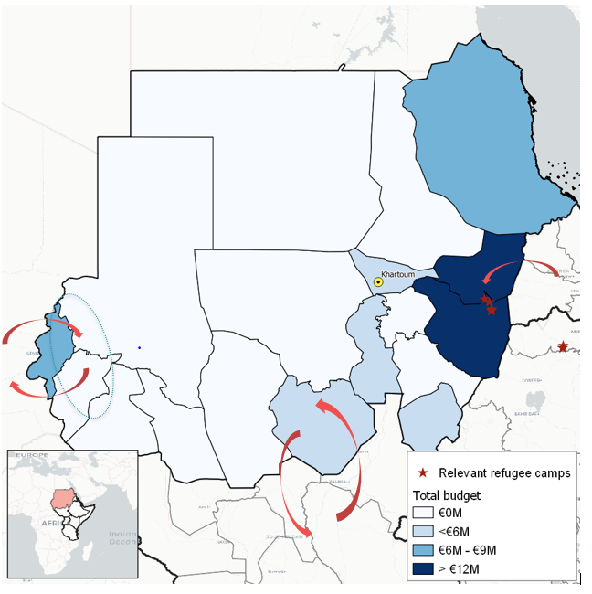
Sudan is a country of origin, destination and transit, located at the very centre of the migration routes linking the Horn and East Africa with Libya and Egypt. It accounts for more than 3.3 million IDPs (mostly in Darfur), and more than 650,000 Sudanese were international migrants and refugees at the end of 2016 (Sudanese refugees are mostly hosted in Chad and South Sudan). Sudan also has a long history of having an ‘open door’ policy to refugees and as a result hosts more than 960,000, including 763,000 South Sudanese and 100,000 Eritreans, as well as around 12,000 Ethiopians and as many as 100,000 Syrians. However, these numbers vary greatly throughout the year and depending on the source referenced, because many registered refugees and asylum seekers move onwards and stay in the country for very little time.
In Sudan, the EUTF priorities are threefold: i) to support the efforts of the government to improve basic services for migrants and host communities and to improve economic opportunities for the general population. Particular emphasis is placed on improving the health and education systems; ii) to improve market opportunities and agricultural resilience to climate-related disasters in the country; and iii) to create alternatives to first and secondary movement and improve the protection of the Sudanese and migrant population in the country, while at the same time making the migratory routes that cross the country safer through regional projects. This last priority also draws from activities implemented under the first two.
Almost 75% of the EUTF’s committed funds in Sudan are aimed at strengthening resilience of communities (Strategic Objective 2). For now, most of the 14 contracted projects are in inception or early implementation, but they are designed to be implemented mostly in areas with high concentrations of IDPs, protracted refugees and returnees. These populations and the host communities are often in need of improved food security and basic services in conflict-affected areas.
The table below lists the programmes that were not included in this report because no contract had been signed yet, the projects were in inception or too early in implementation at the time of reporting.
Table 24: Sudan programmes not included in this report
Programme Name | EUTF ID | Implementing partner(s)
Strengthening Resilience for IDPs, Returnees and Host Communities in West Darfur | T05-EUTF-HoA-SD-12 | CW, IMC
Strengthening resilience for refugees, IDPs and host communities in Eastern Sudan | T05-EUTF-HoA-SD-13 | AICS
Greater Stability in Eastern Sudan through better and more informed decision-making in Food Security | T05-EUTF-HOA-SD-14 | FAO
Education Quality Improvement Programme in Sudan | T05-EUTF-HOA-SD-31 | BC, Expertise France, SC, SOFRECO, UNICEF
Improving Nutrition and Reducing Stunting in Eastern Sudan through an Integrated Nutrition and Food Security Approach | T05-EUTF-HOA-SD-32 | WFP
Livestock Epidemio-Surveillance Project to Support Livelihoods of vulnerable rural smallholders and pastoralists (LESP SLSP) | T05-EUTF-HOA-SD-33 | IFAD
Wadi El Ku integrated catchment management project (Phase 2) | T05-EUTF-HOA-SD-37 | WFP
Technical Cooperation Facility for Sudan | T05-EUTF-HOA-SD-38 | WHO
PROTECT – Protection of Persons of Concern (PoC) and vulnerable migrants along migratory routes in Sudan | T05-EUTF-HOA-SD-43 | Danish Red Cross, IOM
Integrated Measures to promote rural-urban value addition and Employment (IMPROVE-EU) – East Sudan | T05-EUTF-HOA-SD-44 | GIZ
Fostering Smallholder Capacities and Access to Markets in Food Insecure Areas of Darfur | T05-EUTF-HOA-SD-45 | WFP

Table 25: Sudan – Key facts and figures
Overall migration
Total population | 42,166,000
Number of refugees and asylum-seekers in the country | 960,000
Refugees and asylum-seekers stock as % of total population | 2.3%
Top 3 immigrant groups by origin | South Sudan, Eritrea, Ethiopia
Number of internally displaced persons in the country | 3,300,000
Emigrants who left the country | 650,000
HDI Ranking [1 = High - 188 = Low] | 165
EUTF data as of May 2018
Total funds committed so far | €121,000,000
Total funds contracted so far | €59,390,000
Number of programmes with committed funds | 13
Number of projects contracted so far | 14
Q1 report data
Number of projects in report | 2
Number of indicators reported against SO1 | 3
Number of indicators reported against SO2 | 4
Number of indicators reported against SO3 | 0
Number of indicators reported against SO4 | 2
Number of cross-cutting indicators reported | 1

Sudan and the EUTF common output indicators
Table 26: Sudan – Key indicators (results achieved as of March 2018)
1.3 No of people assisted to develop economic income-generating activities | 594
2.4 No of people receiving food security related assistance | 363
4.3 No of people participating in conflict prevention and peace building activities | 60
1.4 No of people benefiting from professional trainings (TVET) and/or skills development | 50
2.8 No of staff from local authorities and basic service providers benefiting from capacity building for strengthening services delivery | 46

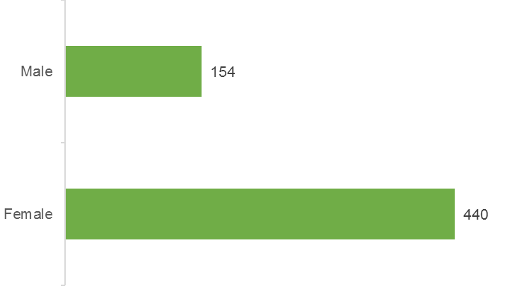
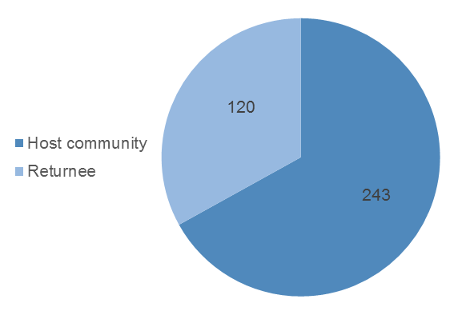
The EUTF-funded projects in Sudan included in this report mainly aim to support the population through TVET (RDPP GIZ) and agricultural-related support and trainings (El Niño ADRA [Adventist Development and Relief Agency]). Women are represented more than men as beneficiaries of IGA support (74%) because they are often in charge of managing the household, making them ideal targets for income-generating activities. According to the figure below, 33% of all people receiving food security related assistance are returnees. These numbers are all informed by ADRA’s activities in White Nile state (El Niño ADRA project). The project does not specifically target returnees, indicating that they are well integrated in the local host communities.
Figure 20: Number of people receiving food security related assistance (EUTF indicator 2.4) in Sudan, by type of beneficiary
Figure 21: Number of people assisted to develop economic income-generating activities (EUTF indicator 1.3) in Sudan, by gender

Sudan – Regional Development and Protection Programme
In Eastern Sudan, Eritrean refugees in protracted situations (that is, who arrived in Sudan between the 1970s and 1990s) live in 9 different camps, while new arrivals are registered in Shagarab (Kassala State). The new arrivals are young, educated people from urban areas, who will often move on quickly rather than live in the camps with no economic or education opportunities (the encampment policy of Sudan and the small number of work permits issued prevent most refugees from obtaining legal employment). As such, some of them will make their way to third countries while others will go to Khartoum, but the influx of refugees combined with rural-urban migration has negatively affected the capacity of the capital to absorb more migrants.
In this context, the ‘Regional Development and Protection Programme’ objectives in Sudan are threefold. First, to enhance the protection of migrants, refugees and asylum seekers, particularly unaccompanied children and victims of trafficking, by improving registration services and providing specific care to persons of concern. UNHCR is responsible for this component, and also aims to advocate for improved access to work permits. The second objective is to improve livelihood opportunities and income-generating activities through vocational training structures, both in Khartoum (UNIDO) and in Gedaref and Kassala (GIZ). The third objective is to improve basic services delivery (AICS) to migrants, refugees, asylum seekers and host communities in Eastern Sudan. Another project in Eastern Sudan, aimed at supporting livelihoods for the population, has yet to be contracted.
Table 27: RDPP SD – Key facts and figures
Key facts and figures
Full programme name | Regional Development and Protection Programme in Sudan: Enhancing alternatives to first and secondary movement from Sudan
Short programme name | RDPP SD
Location(s) of implementation | Eastern Sudan and the urban areas around Khartoum
Total budget | €15,000,000
Total EUTF budget committed | €15,000,000
Date at which EUTF budget was committed | April 2016
Budget contracted so far | €12,000,000
Number of projects | 4
Main IP(s) | AICS, GIZ, UNHCR, UNIDO
Target beneficiaries | Refugees (protracted and new arrivals), asylum seekers, host communities in Sudan
Start date of RDPP GIZ | April 2017
Number of projects in report | 1

Table 28: RDPP SD – Key indicators (results achieved as of March 2018)
1.4 No of people benefiting from professional trainings (TVET) and/or skills development | 50
2.8 No of staff from local authorities and basic service providers benefiting from capacity building for strengthening services delivery | 11

Sudan – Mitigate the effect of El Niño for the host and IDP population in Red Sea, White Nile and North Darfur, Sudan
The ‘Mitigate the effect of El Niño for the host and IDP population in Red Sea, White Nile and North Darfur, Sudan’ programme targets three states that are all characterised by high levels of conflict-driven human displacement and inward migration flows, largely due to their geographical position at the borders of the country.
The programme aims to strengthen the resilience of local communities, displaced populations and potential migrants in these states to avoid a deterioration of the food security and economic situation, which would fuel more human displacement. Activities implemented under the programme should lead to improved access to water (through mappings, needs assessments and the strengthening or development of new water management systems) and to increased income opportunities linked to drought-resistant agriculture and income generating activities. The El Niño SD programme is implemented by the Adventist Development and Relief Agency (ADRA) in White Nile State, Welthungerhilfe (WHH) in Red Sea State, and should be implemented by Cooperazione Internazionale (COOPI) in North Darfur, although this third contract is not yet signed.
Table 29: El Niño SD – Key facts and figures
Key facts and figures
Full programme name | Mitigate the effect of El Niño for the host and IDP population in Red Sea, White Nile and North Darfur, Sudan
Short programme name | El Niño SD
Location(s) of implementation | Red Sea, White Nile and North Darfur
Total budget | €9,601,205
Total EUTF budget committed | €8,000,000
Date at which EUTF budget was committed | October 2016
Budget contracted so far | €5,000,000
Number of projects | 2
Main IP(s) | ADRA, WHH
Target beneficiaries | Host communities and refugees, IDPs and migrants
Number of projects in report | 1

Table 30: El Niño SD – Key indicators (results achieved as of March 2018)
1.3 No of people assisted to develop economic income-generating activities | 594
2.4 No of people receiving food security related assistance | 363
4.3 No of people participating in conflict prevention and peace building activities | 60
2.8 No of staff from local authorities and basic service providers benefiting from capacity building for strengthening services delivery | 35
5.1 No of multi-stakeholder groups and learning mechanisms formed and regularly gathering | 10

Somalia

Somalia’s migration profile
Figure 22: Key programmes and migration flows in Somalia, May 2018
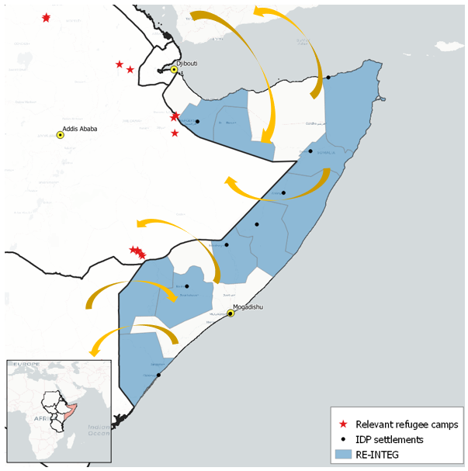
Somalia’s unstable political context, compounded by environmental challenges such as droughts and desertification, has led large numbers of people to flee to neighbouring countries and displaced millions internally. A severe drought in 2017 left almost 7 million individuals in need of urgent food assistance, and many feared a repeat of the dramatic 2011 famine, during which an estimated 260,000 people lost their lives, of whom half were children. 2018 estimates suggest that the number of internally displaced people may be well above 2 million,.
The EUTF’s main efforts in the country are aimed at providing livelihood opportunities, ensuring basic service provision and guaranteeing the safe and dignified return and reintegration of Somalis in stable areas of the country. Around 110,000 Somali refugees have been repatriated since 2014, around 70% of whom came back from Kenya.
Migration flows
Political instability and droughts regularly displace huge portions of the Somali population (more than 10% of the population is currently internally displaced). Thousands of migrants are reportedly attempting the dangerous crossing of the Gulf of Aden, mostly from the State of Puntland. Most are looking to settle in one of the Gulf countries – usually the Kingdom of Saudi Arabia (KSA). However, many of those who successfully arrive are currently being repatriated on account of the KSA government’s security crackdown as part of the Nation Without Illegal Expats campaign launched in November 2017.
Important migration flows also take place along the borders with Kenya (with Kenyan citizens reportedly trying to cross and settle in Somalia, and Somali citizens moving in both directions, partly due to proximity to the Dadaab refugee camp, the population of which consists of mostly Somali refugees) and with Ethiopia (mainly Ethiopians returning to their country).
Table 31: Somalia – Key facts and figures
Overall migration data
Total population | 14,300,000
Number of internally displaced people | 2,100,000
Number of international migrants in the country | 44,900
International migrant stock as % of total population | 0.30%
Emigrants who left the country | 2,000,000
Top 3 migrant groups by country of origin | Ethiopia, Yemen, Eritrea
Number of returnees since 2014 | 110,000
HDI Ranking [1 = High - 188 = Low] | N/A
EUTF data as of May 2018
Total funds committed so far | €113,000,000
Total funds contracted so far | €51,060,000
Number of programmes with committed funds | 5
Number of projects contracted so far | 12
Q1 report data
Number of projects in report | 8
Number of indicators reported against SO1 | 6
Number of indicators reported against SO2 | 7
Number of indicators reported against SO3 | 7
Number of indicators reported against SO4 | 5
Number of cross-cutting indicators reported | 2

Somalia programmes not reported on herewith due to being in inception phase or not yet contracted include Promoting a culture of tolerance and dialogue in Somalia, RESTORE - Building Resilience in Northern Somalia, where a €4M contract has been signed with NRC, Enhancing security and the rule of law in Somalia and RESTORE 2 Building Resilience in Northern Somalia.

Somalia and the EUTF common output indicators
Table 32: Somalia – Key indicators (results achieved as of March 2018)
3.2 No of migrants in transit, victims of human trafficking, children in the mobility, IDPs and refugees protected or assisted. | 36,970
2.2 No of people receiving a basic social service | 25,314
3.5 No of returning migrants benefiting from reintegration assistance | 20,287
2.7 No of people reached by information campaigns on resilience-building practices and basic rights | 6,906
3.4 No of voluntary returns or humanitarian repatriation supported | 3,955

All the results for Somalia have been achieved by REINTEG, the only programme in Somalia with indicators to report on at this point.

Somalia – RE-INTEG: Enhancing Somalia’s responsiveness to the management and reintegration of mixed migration flows
‘RE-INTEG: Enhancing Somalia’s responsiveness to the management and reintegration of mixed migration flows’ is one of the largest EUTF-funded programmes, with a budget of €50M. There are currently an estimated 2.1 million internally displaced individuals in Somalia, around 1 million Somali refugees registered in the HoA/Yemen region, and many other irregular migrants from Somalia spread across the region. On the hand, geo-political dynamics in the area are also causing a reverse flow of migration towards Somalia.
RE-INTEG aims to assist the country in ensuring a durable integration of refugees and IDPs and in anchoring populations within Somalia. To that end, the programme seeks to build the government’s capacity to manage return flows, support the implementation of policies and legal frameworks aimed at enhancing the rule of law for migrants, strengthen cross-border cooperation, and improve access to basic services and to livelihoods opportunities in the main accessible areas of return and departure.
Table 33: RE-INTEG Somalia – Key facts and figures
Key facts and figures
Full programme name | Enhancing Somalia's responsiveness to the management and reintegration of mixed migration flows
Short programme name | RE-INTEG
Location(s) of implementation | Banaadir, Bari, Bay, Galguduud, Gedo, Hiiraan, Jubbada Hoose, Mudug, Nugaal, Togdheer, Woqooyi Galbeed
Total budget | €50,000,000
Total EUTF budget committed | €50,000,000
Date at which EUTF budget was committed | December 2015
Budget contracted so far | €47,000,000
Number of projects | 10
Main IP(s) | CARE, CW, DRC, IDLO, IOM, NRC, UNHCR, UN Habitat, WV
Target beneficiaries | IDPs, refugees, returnees and host communities across Somalia and Somaliland
Number of projects in Q1 | 8

Focus box 5: Some RE-INTEG highlights
- IGA
Over 3,000 beneficiaries have been supported in developing an IGA by the RE-INTEG programme in Somalia, through the two projects implemented by World Vision (WV) and UNHCR. Of these, over half are female and almost 1,000 are female returnees.
Figure 23: No of beneficiaries assisted to develop IGAs (EUTF indicator 1.3) by beneficiary type and gender
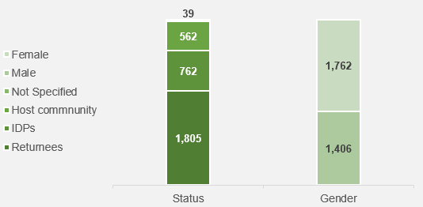
- Basic Services
Some 25,314 beneficiaries, of whom 14,590 were returnees and 12,776 were women, were provided a basic service thanks to RE-INTEG’s intervention in Somalia (the main service being education with 23,963 beneficiaries).
Figure 24: People provided with a basic service (EUTF indicator 2.2) in Somalia, by beneficiary status and gender
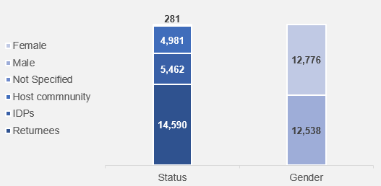
- Training of state and non-state staff on human rights
205 (90 females) staff from governmental institutions, internal security forces and relevant non-state actors have been trained on security, border management, CVE, conflict prevention, protection of civilian populations and human rights (EUTF indicator 4.2) through RE-INTEG. The main topic covered was human rights.

Kenya

Kenya’s migration profile
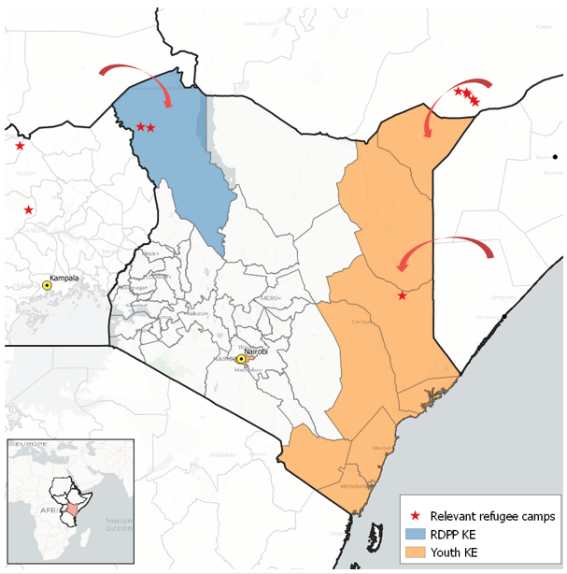
Figure 25: Key programmes and migration flows in Kenya, May 2018
Kenya currently hosts 486,460 refugees and asylum seekers, mostly from South Sudan and Somalia. Most refugees and asylum seekers live in camps – namely in Dadaab (235,000 people, mostly from Somalia) and Kakuma / Kalobeyei (185,000 people, mostly South Sudanese refugees). In recent months, the north of the country has also witnessed an influx of Ethiopians fleeing violence in Oromo.
In May 2016, the government announced its intention to close the Dadaab camp (which, in 2012, was the largest refugee camp in the world, hosting about 500,000 people). The decision was reversed by the High Court of Kenya, but new arrivals have not been registered in the camp since then and the Kenyan government aims to assist the return of Somalis in collaboration with UNHCR (76,500 Somalis were returned between December 2014 and December 2017).
The EUTF priorities in the country are: i) to provide opportunities and protection for the large number of South Sudanese and Somalis in situations of protracted displacement in the country and for the host communities; ii) to accompany the government in its efforts to prevent and counter violent extremism; iii) to promote social cohesion and youth employment. Most of the disbursed funds of the EUTF in the country are therefore evenly spread over 3 EUTF strategic objectives: greater economic and employment opportunities (Strategic Objective 1), Strengthening resilience of communities (Strategic Objective 2) and Improved governance (Strategic Objective 4). The main beneficiaries of these activities are youth at risk and vulnerable to being recruited by violent extremism groups, as well as refugees and asylum seekers.
Table 34: Kenya – Key facts and figures
Overall migration data
Total population | 48,500,000
Number of refugees and asylum-seekers in the country | 486,460
International migrant stock as % of total population | 1%
Emigrants who left the country | 475,499
Top 3 immigrant groups by origin | Somalia, South Sudan, Congolese
HDI Ranking [1 = High - 188 = Low] | 146
EUTF data as of May 2018
Total funds committed so far | €34,000,000
Total funds contracted so far | €28,360,000
Number of programmes with committed funds | 3
Number of projects contracted so far | 5
Q1 report data
Number of projects in report | 5
Number of indicators reported against SO1 | 5
Number of indicators reported against SO2 | 8
Number of indicators reported against SO3 | 0
Number of indicators reported against SO4 | 4
Number of cross-cutting indicators reported | 3

Kenya and the EUTF common output indicators
Table 35: Kenya – Key indicators (results achieved as of March 2018)
2.2 No of people receiving a basic social service | 62,034
2.7 No of people reached by information campaigns on resilience-building practices and basic rights | 38,557
1.4 No of people benefiting from professional trainings (TVET) and/or skills development | 19,422
4.3 No of people participating in conflict prevention and peace building activities | 10,718
2.4 No of people receiving food security related assistance | 8,828

In Kenya, 62,034 people have received at least one basic service (EUTF indicator 2.2) as a result of EUTF- funded activities. Of these, 96% are refugees, and all have been reached by awareness raising campaigns on resilience building activities (EUTF indicator 2.7). These figures refer to the population of the Kalobeyei integrated settlement, where the RDPP Kenya implements its activities. Additionally, 8,828 people - of whom 77% are women - have been supported through food security assistance activities (EUTF indicator 2.4).

Figure 26: Number of people receiving a basic social service (EUTF indicator 2.2) in Kenya, by type of service  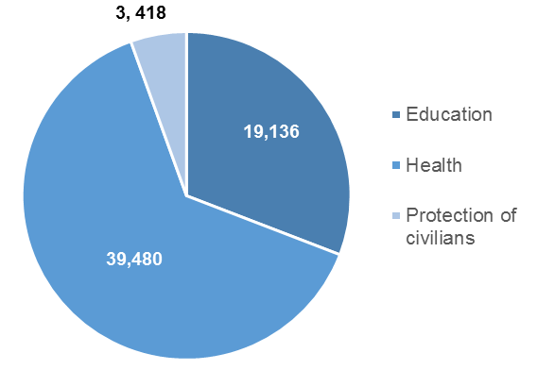 | Figure 27: Number of people receiving food security assistance (EUTF indicator 2.4) in Kenya, by gender  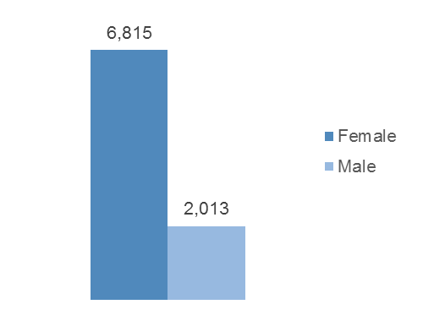

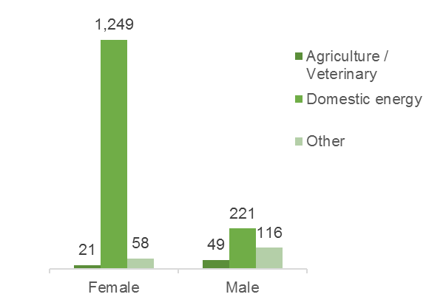
The jobs created with EUTF support in Kenya are mostly attributable to people targeted and supported by the RDPP Kenya programme.
Figure 28: Number of jobs created (EUTF indicator 1.1) in Kenya, by gender and type of activity
Women are more targeted for domestic energy related jobs (1,249) – first because they tend to be more vulnerable, and second because it allows them to gain financial independence.

Out of the 10,718 beneficiaries participating in conflict prevention activities in Kenya, 10,489 are youth. On the coast, the Youth programme specifically targets youth who are at risk of being recruited by violent extremist groups.  Most (90%) of the beneficiaries have taken part in some type of awareness-raising exercise held by one of the four EUTF-funded projects under the Youth programme. | Figure 29: Number of people participating in conflict-prevention and peace-building activities (EUTF indicator 4.3) in Kenya by type of activity
 | 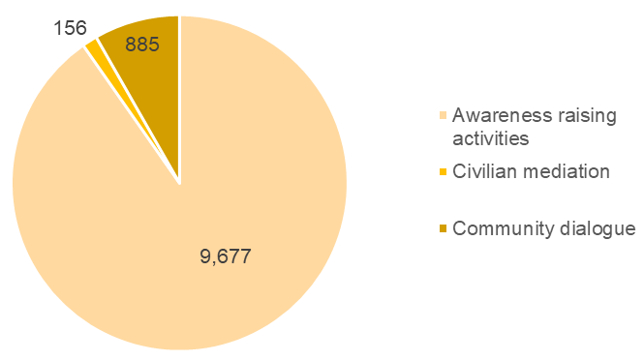

Kenya – Regional Development and Protection Programme: Support to the Kalobeyei Development Programme
The ‘Regional Development and Protection Programme in Kenya: Support to the Kalobeyei Development Programme’ targets the population of Kalobeyei, a new settlement built to accommodate the increasing number of refugees in the Kakuma refugee camp in Turkana County. Jointly implemented by UNHCR, UNICEF, WFP and FAO, the programme is part of the Kalobeyei Integrated Social and Economic Development Plan (KISEDP), a 14-year initiative designed to develop the local economy and service delivery in Kalobeyei. It will contribute to the establishment of an integrated settlement area, in which refugees and the host community live together peacefully, have access to social services and develop economic ties to build sustainable livelihoods.
In particular, the programme will support equal access to primary health care, education, and child protection services for both refugees and the host community, improved capacity for agricultural production, and access to improved livelihoods opportunities through value chain creation and entrepreneurship support.
Table 36: RDPP Kenya – Key facts and figures
Key facts and figures
Full programme name | Regional Development and Protection Programme in Kenya: Support to the Kalobeyei Development Programme
Short programme name | RDPP KE
Location(s) of implementation | Kalobeyei integrated settlement, Turkana county
Total budget | €32,377,105
Total EUTF budget committed | €15,000,000
Date at which EUTF budget was committed | April 2016
Budget contracted so far | €14,700,000
Number of projects | 1
Main IP(s) | UNHCR in a consortium with FAO, UNICEF, WFP
Target beneficiaries | Host communities and refugees of the settlement (majority from South Sudan)
Start date | July 2016
End date | July 2019
Number of projects in report | 1

Table 37: RDPP Kenya – Key indicators (results achieved as of March 2018)
2.2 No of people receiving a basic social service | 62,034
2.7 No of people reached by information campaigns on resilience-building practices and basic rights | 38,557
1.4 No of people benefiting from professional trainings (TVET) and/or skills development | 19,016
2.4 No of people receiving food security related assistance | 8,828
1.3 No of people assisted to develop economic income-generating activities | 2,177

Kenya – Conflict prevention, peace and economic opportunities for the youth
The ‘Conflict prevention, peace, and economic opportunities for the youth’ programme groups together activities that mainly target at-risk youths in Kenya. It is implemented by four organisations in high-risk areas in Nairobi, north-eastern Kenya and on the coast. The latter two areas have generally been excluded from the national development process, and all are increasingly becoming transit points for irregular migration routes and / or high-risk areas for radicalised youth.
The programme aims to conduct research to strengthen understanding of the underlying causes of conflict and violence (including violent extremism), give youths access to better vocational training and entrepreneurship opportunities, improve conflict management and prevention, particularly by mentoring at-risk youth and building the capacity of political and security actors to answer security threats, and assisting smallholder farmers to access better market opportunities. The programme will target a total of 6,500 youths for increased access to vocational training, and 4,000 youths will be provided with conflict management skills.
This project is the object of a Learning case study that is briefly introduced in the focus box 6 below and will be developed in June – July through field research in several regions of Kenya.
Table 38: Youth Kenya – key facts and figures
Key facts and figures
Full programme name | Conflict prevention, peace and economic opportunities for the youth
Short programme name | Youth KE
Location(s) of implementation | Garissa, Kilifi, Kwala, Lamu, Mandera, Mombasa, Nairobi, Taita-Taveta, Tana River and Wajir counties
Total budget | €14,350,000
Total EUTF budget committed | €14,000,000
Date at which EUTF budget was committed | April 2016
Budget contracted so far | €13,660,000
Number of projects | 4
Main IP(s) | GIZ, KRCS, RUSI, SAIDC
Target beneficiaries | Youth at risk and vulnerable in the targeted counties
Number of projects in report | 4

Table 39: Youth Kenya – Key indicators (results achieved as of March 2018)
4.3 No of people participating in conflict prevention and peace building activities | 10,718
4.2 No of staff from governmental institutions, internal security forces and relevant non-state actors trained on security, border management, CVE, conflict prevention, protection of civilian populations and human rights | 471
1.4 No of people benefiting from professional trainings (TVET) and/or skills development | 406
1.3 No of people assisted to develop economic income-generating activities | 268
1.5 No of job placements facilitated and/or supported | 139

Focus box 6: Introduction to the MLS case study on the Conflict prevention, peace and economic opportunities for the youth in Kenya programme
In parallel to the Youth Kenya projects, EU DEVCO is funding a related project implemented by the Aga Khan Foundation (AKF) in the same thematic and geographic areas.
Identifying synergies and areas of collaboration: Although the four projects share similar objectives and geographic focuses, collaboration is currently largely limited to monthly steering committees. In this regard, the organisations and the EU management have expressed the wish to reinforce and operationalise synergies between the four sub-projects and asked the MLS team to investigate pathways to improve synergies between the different partners involved. Through meetings with major stakeholders and fieldwork in coastal counties where the organisations are implementing their activities, the MLS team will aim to identify areas of collaboration and formulate practical recommendations to maximise the synergies between the four organisations.
Possible synergies identified during the inception phase include the harmonisation and sharing of best practices in the fields of targeting, recruitment, mobilisation, research, communications, M&E, and relationships with partners, as well as giving beneficiaries the option of taking part in activities implemented by different organisations.
This will be further assessed and developed through the case study, which should be finalised by July 2018.

Uganda

Uganda’s migration profile
Figure 30: Key programmes and migration flows in Uganda, May 2018
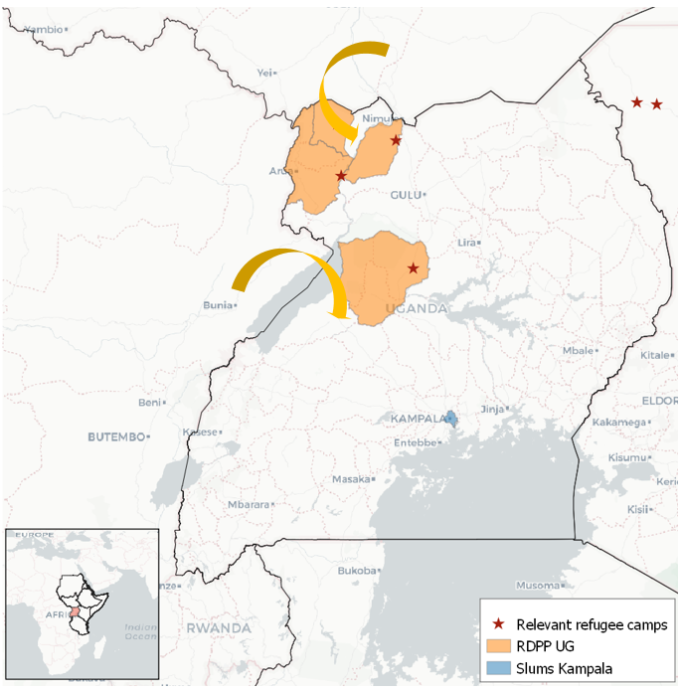
Uganda has a long history of hosting asylum seekers from all over East and Central Africa. Its geographic location, just south of South Sudan and east of the Democratic Republic of the Congo (DRC), are among the reasons for its enormous refugee population of 1.46 million. Of these, almost 50% are under 15 years old and over 80% are South Sudanese while many of the others come from the DRC. Tens of thousands of South Sudanese refugees fled to Uganda in the first half of 2017, following the escalation of conflicts in East, Central and Western Equatoria. Many of them have settled in the northern part of Uganda, with 950,000 in the districts of Adjumani, Arua, Moyo and Yumbe alone.
The political and humanitarian crisis in the DRC is also forcing thousands of Congolese out of the country. Uganda is currently hosting 285,398 Congolese refugees. It is estimated that in 2018 alone over 50,000 Congolese have entered Uganda, with many doing so by crossing Lake Albert (situated on the border between the two countries), often on small and overcrowded boats. UNHCR reported that at the beginning of February 2018, over a period of just three days, more than 22,000 Congolese made the crossing.
As the nation hosting the largest number of refugees in Africa, Uganda sets a positive example in terms of generous and progressive policies on migration and asylum granting. However, the situation in the northern part of Uganda is of particular concern given the dramatic increase in refugee arrivals in recent years and the intercommunal conflicts that have arisen as a result.
It is also worth noting that like other countries in the region, Uganda has a high population growth rate (around 3.3% in 2016). It is expected that by 2050, the country’s population will reach an impressive 130 million, from the current 41.5. This trend obviously poses new challenges for its government and society, and also represents a potential source of conflict for land and resources.

Table 40: Uganda – Key facts and figures
Overall migration data
Total population | 41,500,000
Number of international migrants in the country | 1,462,886
International migrant stock as % of total population | 3.5%
Emigrants who left the country | 501,200
Top migrant groups by origin | South Sudan, the DRC, Rwanda
HDI Ranking [1 = High - 188 = Low] | 146
EUTF data as of May 2018
Total funds committed so far | €44,300,000
Total funds contracted so far | €24,100,000
Number of programmes with committed funds | 3
Number of projects contracted so far | 4
Q1 report data
Number of projects in report | 4
Number of indicators reported against SO1 | 4
Number of indicators reported against SO2 | 6
Number of indicators reported against SO3 | 1
Number of indicators reported against SO4 | 4
Number of cross-cutting indicators reported | 2

Uganda and the EUTF common output indicators
Table 41: Uganda – Key indicators (results achieved as of March 2018)
2.3 No of people receiving nutrition assistance | 27,462
1.3 No of people assisted to develop economic income-generating activities | 11,447
4.2 No of staff from state and relevant non-state actors trained on security, border management, CVE, conflict prevention, protection of civilian populations and human rights | 6,046
2.2 No of people receiving a basic social service | 5,177
1.1 No of jobs created | 1,918

So far, a total of 1,918 jobs have been created (EUTF indicator 1.1) by the EUTF projects in Uganda, including 1,344 for female beneficiaries. The jobs are divided among those becoming successfully self-employed following IGA support, people employed in MSMEs that received funding from the programme, cash for work activities and short-term jobs.
Some 949 beneficiaries have completed professional trainings (TVET) and / or skills development trainings (EUTF indicator 1.4) - and many more are currently enrolled - thanks to IOM’s Strengthening social cohesion and stability in slums populations programme (649 beneficiaries) and the RDPP Support Programme for Refugee and Host Communities in Northern Uganda (SPRS-NU). The RDPP Enabel project is particularly dedicated to the development of the education sector in Uganda, and in parallel is supporting the enrolment of students in instant trainings and TVETs (94 beneficiaries have completed instant trainings so far) to provide them with skills for their future employment.
Figure 31: Beneficiaries of professional trainings (TVET) and/or skills development trainings (EUTF indicator 1.4), by status and gender
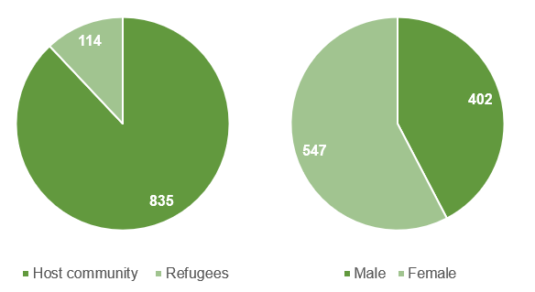

6,046 staff from governmental institutions, internal security forces and relevant non-state actors have been trained on security, border management, CVE, conflict prevention, protection of civilian populations and human rights (EUTF indicator 4.2). The main topic covered was conflict prevention (5,683 people), and 58% of participants were female.
Figure 32: Staff trained on conflict prevention, border management and human rights (EUTF indicator 4.2) by displacement status and training topic
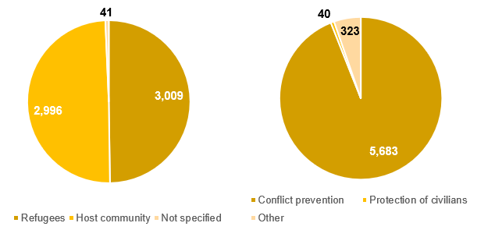
5,693 of those trained by the programme were trained by the Danish Refugee Council. These trainings on alternative dispute mechanisms and legal processes were carried out in the northern part of the country and targeted local government officials, community leaders, local courts run by Refugee Welfare Councils (RWCs), and traditional/tribal leaders. 53% of those attending the trainings were refugees, likely on account of the very high density of refugee populations in the targeted areas (Arua, Adjumani, Yumbe, Kiryandongo).

Uganda – Regional Development and Protection Programme
Uganda currently hosts over 1.4 million refugees. When renewed conflict broke out in South Sudan in July 2016, an unprecedented number of refugees came to Uganda, doubling the refugee population in less than seven months. Uganda has since become the largest refugee-hosting country in Africa. Despite the challenges generated by the new influx from South Sudan, Uganda maintains one of the most progressive approaches to refugee protection and has volunteered to pilot the application of the Comprehensive Refugee Response Framework (CRRF). At the heart of this approach is the idea that refugees should be included in the communities from the very beginning.
The ‘RDPP Support Programme to the Refugee Settlements and Host Communities in Northern Uganda (SPRS-NU)’ aims to reduce risks of violence between the refugee and host communities in several refugee hosting districts in northern Uganda, including Adjumani, Arua, Kiryandongo and Yumbe. The intervention logic and overall theory of change suggest that by jointly providing the two communities with livelihood assets, improved service delivery and conflict mitigation tools, relations between the two parties will improve. The specific objectives are aligned with the regional objectives of the RDPP for the Horn of Africa.

Table 42: RDPP SPRS-NU – Key facts and figures
Key facts and figures
Full programme name | Regional Development and Protection Programme (RDPP): Support Programme to the Refugee Settlements and Host Communities in Northern Uganda (SPRS-NU)
Short programme name | RDPP SPRS-NU
Location(s) of implementation | Adjumani, Arua, Kiryandongo, Yumbe
Total budget | €20,000,000
Total EUTF budget committed | €20,000,000
Date at which EUTF budget was committed | December 2015
Budget contracted so far | €19,800,000
Number of projects | 3
Main IP(s) | ADA, DRC, Enabel
Target beneficiaries | Host community and South Sudanese refugees
Number of projects in report | 3
Table 43: RDPP SPRS-NU – Key indicators (results achieved as of March 2018)
2.3 No of people receiving nutrition assistance | 27,462
1.3 No of people assisted to develop economic income-generating activities | 11,320
4.2 No of staff from governmental institutions, internal security forces and relevant non-state actors trained on security, border management, CVE, conflict prevention, protection of civilian populations and human rights | 5,693
2.2 No of people receiving a basic social service | 5,177
1.1 No of jobs created | 1,754

Focus box 7: RDPP SPRS-NU DRC’s livelihood groups
The creation of livelihood groups is the cornerstone of the RDPP DRC project in northern Uganda: 1,151 livelihood groups, including both host and refugee members (for a total of respectively 11,894 and 15,568 individuals involved, with 62% female members), have been created within the project. The members are, among others, provided nutrition assistance (through trainings and information sessions) and supported in IGA creation and employment. One of the key objectives of these groups is to stimulate cooperation and dialogue between the refugee and host community.
Table 44: Livelihood groups indicators, RDPP SPRS-NU DRC
 | Host community | Refugee community
2.3 No of people receiving nutrition assistance | 11,894 | 15,568
1.3 No of people assisted to develop economic income-generating activities | 4,959 | 4,881
1.1 No of jobs created | 984 | 584

Uganda – Strengthening social cohesion and stability of slums populations
Population growth in the country poses, among other issues, a challenge for urban integration. The intervention logic for the ‘Strengthening social cohesion and stability of slums populations’ programme addresses the root causes of intercommunal conflicts in some of the most problematic areas of the capital (Kampala), both between and within refugee and host communities. Through the organisation of townhall meetings, awareness campaigns and social engagement activities, the action aims to integrate marginalised and vulnerable groups and to strengthen community cohesion and inclusive development. In parallel, trainings and dialogues will be carried out with public institutions and security forces to improve their capacity and accountability systems.
The programme ultimately aims to increase economic opportunities, improve access to basic services, and strengthen resilience to messages of violence.
Table 45: SSCoS – Key facts and figures
Key facts and figures
Full programme name | Strengthening social cohesion and stability in slums populations
Short programme name | SSCoS
Location(s) of implementation | Kampala
Total budget | €4,741,423 (includes €441,423 co-funding from IOM)
Total EUTF budget committed | €4,300,000
Date at which EUTF budget was committed | December 2015
Budget contracted so far | €4,300,000
Number of projects | 1
Main IP(s) | IOM
Target beneficiaries | Host and refugee communities
Start date | August 2016
End date | February 2020
Number of projects in report | 1

Table 46: SSCoS – Key indicators (results achieved as of March 2018)
1.4 No of people benefiting from professional trainings (TVET) and/or skills development | 649
4.3 No of people participating in conflict prevention and peace building activities | 370
4.2 No of staff from governmental institutions, internal security forces and relevant non-state actors trained on security, border management, CVE, conflict prevention, protection of civilian populations and human rights | 353
1.1 No of jobs created | 164
1.3 No of people assisted to develop economic income-generating activities | 127

Djibouti

Djibouti’s migration profile
Figure 33: Key programmes and migration flows in Djibouti, May 2018
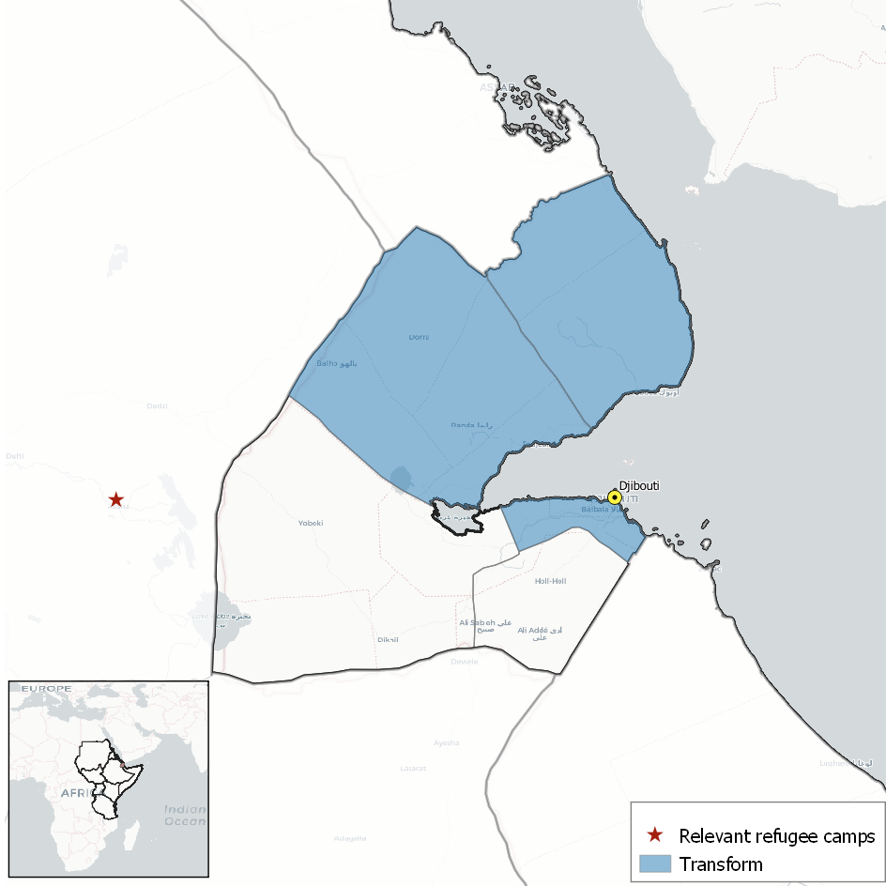
Djibouti’s unique migration profile is above all shaped by its location as a transit point along an ancient migratory route from the Horn of Africa to the Arabian Peninsula. Although the popularity of this route has fluctuated throughout history, Djibouti’s role as a gateway to the Gulf of Aden, particularly for Ethiopians seeking to migrate to the KSA for economic reasons, has grown exponentially over the past decade. The journey is extremely dangerous at almost every stage, with risks including water scarcity while crossing the desert in Djibouti, rough seas in the Gulf of Aden, conflict in Yemen, deportation upon arrival in the KSA, and the danger of human trafficking and abuse at the hands of smugglers.
To support the effective management of this increasingly important migratory route, the EUTF has allocated funding for Djibouti within the scope of regional programmes designed to improve migration management and facilitate voluntary returns and reintegration, such as BMM and the RRF.
There are also more than 27,000 refugees currently registered in Djibouti, mainly of Ethiopian, Eritrean, Somali and Yemeni origin. In December 2017, following the support and advocacy of UNHCR and in conformance with Djibouti’s participation in the CRRF, Djibouti signed several laws into force with the aim of improving job opportunities, promoting socio-economic integration, and facilitating access to social services for refugees living in Djibouti.
The needs of the local population are also pronounced, with nearly a quarter of Djiboutians living in extreme poverty despite steady economic growth over the past 15 years. Djibouti’s geopolitically strategic location, bolstered by improvements to its port and transport infrastructure, have enabled the construction and trade industry to flourish, but failure to reconcile the capacity and skills of the local population with the demands of the evolving labour market has meant that Ethiopians and other nationals are often hired to fill these new positions. As a result, the national labour force participation rate has stagnated at less than 25%. The EUTF has identified this ‘structural unemployment’ as a potential risk for fostering ‘internal tensions’, and addressing this is a priority action for the Fund in Djibouti. The EUTF has invested in a project led by the Agence Française de Développement (AFD) to improve the skills and employability of youths for service in the port and transport sectors (the project has no data to report at this stage).
Table 47: Djibouti – Key facts and figures
Overall migration data
Total population | 942,300
Number of international migrants in the country | 116,100
International migrant stock as % of total population | 12.1%
Emigrants who left the country | 15,800
Top 3 migrant groups by country of origin | Somalia, Ethiopia, Yemen
HDI Ranking [1 = High - 188 = Low] | 172
EUTF data as of May 2018
Total funds committed so far | €25,000,000
Total funds contracted so far | €10,000,000
Number of programmes with committed funds | 2
Number of projects contracted so far | 1
Number of projects in report | 0

Analysis by Strategic Objective
According to its Strategic orientation document, the EUTF organises its funding according to four main strategic objectives: 1. Greater economic and employment opportunities (currently second in terms of funding with €151M); 2. Strengthening resilience of communities (first in terms of funding with €196M); 3. Improved migration management (fourth with €60M) and; 4. Improved governance and conflict prevention (with €92M contracted thus far). A fifth cross-cutting area addresses improved policy and practice (standing close to €17M). This section will dive deeper into selected key indicators from the four main strategic objectives. However, as previously mentioned, because these indicators do not reflect the entire breadth of EUTF-funded projects in the HoA, this analysis should be considered to capture only certain specific aspects of the HoA portfolio.

Greater economic and employment opportunities
Figure 34: Countries in the EUTF HoA by funds spent on SO1 - Greater economic and employment opportunities

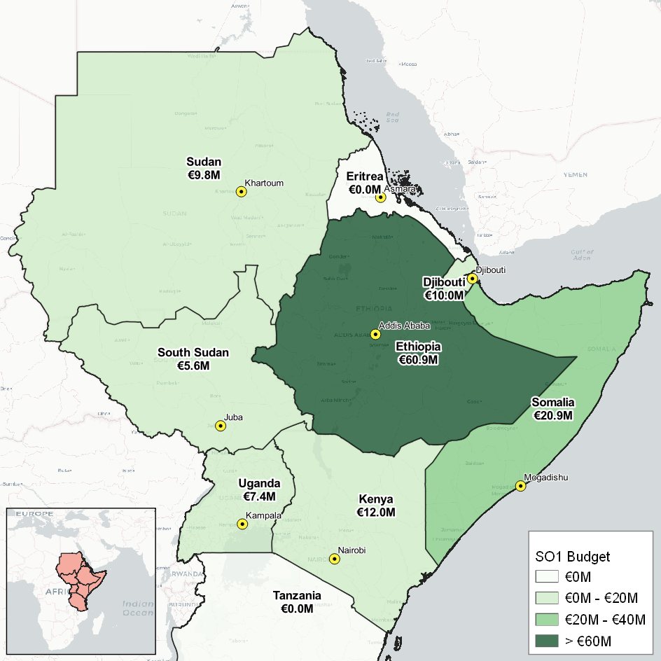

SO1 is the second largest in terms of funding thus far received, and is covered by 8 main EUTF common output indicators. Most of the outputs for this SO and in the HoA so far fall under EUTF indicator 1.3 (IGA), 1.4 (TVET and skills development) and 1.5 (job placements and incentives), followed more distantly by 1.1 (jobs created), as many projects focus on supporting all types of beneficiaries (refugees, returnees, IDPs, host communities, and men and women alike) to develop skills and income-generating activities. Some of the more striking results for selected indicators under this SO are detailed below.

EUTF indicator 1.1 – Number of jobs created
Figure 35: Number of jobs created and/or supported (EUTF indicator 1.1), disaggregated by type of job
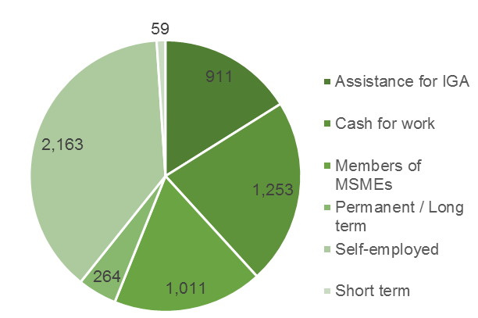
Overall, the EUTF-funded projects in the region have contributed to the creation of 5,661 jobs so far. Women comprise 70% of the jobs created, mostly in self-employed positions because of the projects’ emphasis on targeting women (who are often the heads of the most vulnerable households) for income-generating activities. Host communities represent 3,288 out of the 5,661 jobs created, likely because the development of an IGA is often linked to the ownership of a house, land and connections to the market. The RDPP Kenya project alone has supported the creation of 1,550 self-employed positions, largely by certifying and supporting producer groups with domestic energy (charcoal) production.

EUTF indicator 1.4 – Number of people benefiting from professional training (TVET) and/or skills development

In the HoA region, 21,587 people have been supported through activities related to TVET and / or skills development. Once again, most of the beneficiaries are women (almost 60%), who are targeted because they are often more vulnerable.
Figure 36: Number of people benefiting from professional training (TVET) and/or skills development (EUTF indicator 1.4), disaggregated by country

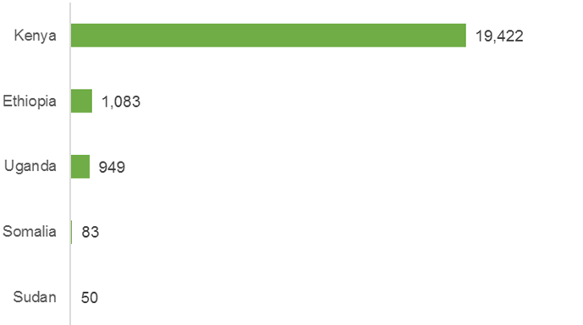
19,422 of the people trained and supported in skills development are in Kenya, where the population (host and refugee) lacks job opportunities and market-oriented skills. By improving their skills (through on-the-job training or TVET activities), the projects ensure that the beneficiaries will be able to find placements and / or increase their income.

Strengthening resilience of communities
SO2 represents the largest proportion of funding for the EUTF, with €196M contracted so far. This is largely due to programmes such as RESET II in Ethiopia, IMPACT and HPFII In South Sudan, and some of the work done by RE-INTEG and the RDPP projects. SO2 is covered by 10 EUTF common output indicators: some of the ones with the largest numbers are EUTF indicators 2.9 (people having improved access to basic services), 2.2 (people receiving one basic service) and 2.7 (people reached by information campaigns on resilience building practices and basic rights).
Figure 37: Countries in the EUTF HoA by funds spent on SO2 – Strengthening resilience of communities

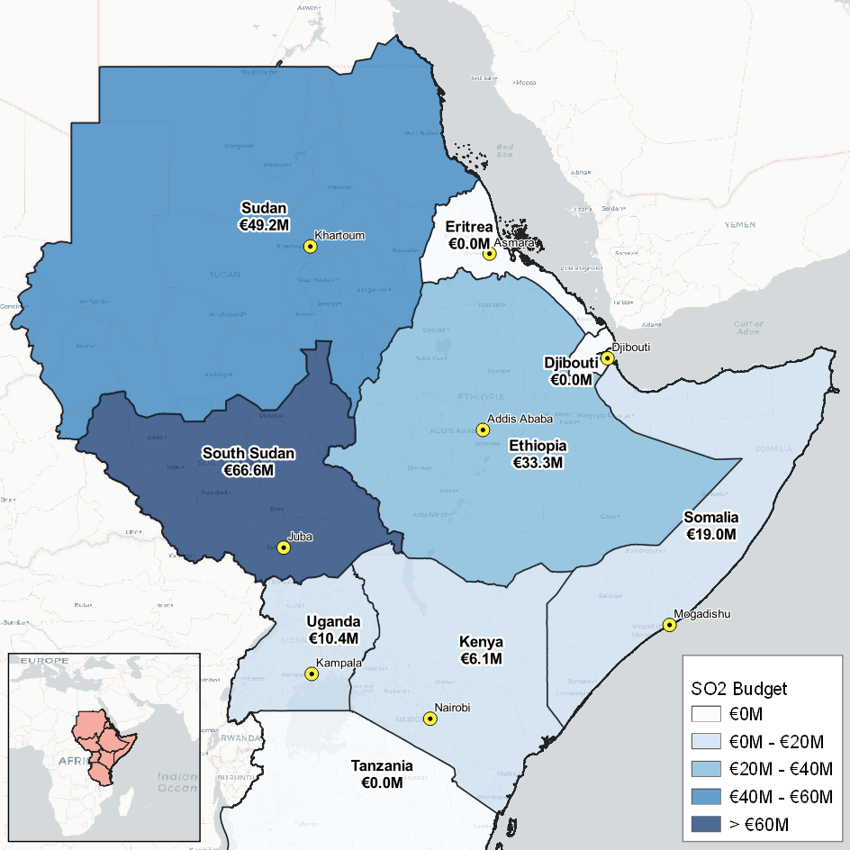

EUTF indicator 2.1 – Number of social infrastructure built or rehabilitated
A total of 117 social infrastructures have been built or rehabilitated by the different projects analysed in this report. A large majority of this infrastructure is located in Ethiopia and Somalia, as RDPP Ethiopia, RESET II, and RE-INTEG have built or rehabilitated a combined total of 105 facilities, including a total of 44 water points or systems built or rehabilitated by RESET II, and 28 education facilities constructed or rehabilitated in Somalia by RE-INTEG.
Figure 38: Number of social infrastructures built or rehabilitated (EUTF indicator 2.1b), by type of infrastructure
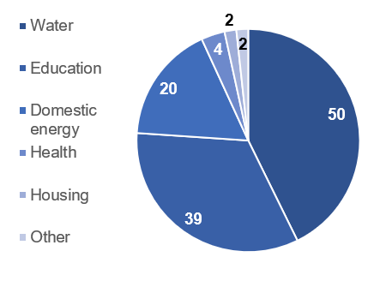

EUTF indicator 2.2 – Number of people receiving a basic social service
Over 1.7 million EUTF project beneficiaries have been provided with a basic social service in the HoA. This figure is largely driven by the Health Pooled Fund II programme implemented by DFID in South Sudan. HPF II provides increased access to quality health services, particularly targeting children, pregnant women and other vulnerable groups. Since the beginning of its implementation, EUTF funding (which represents around 11.4% of total HPFII funding) has helped it assist over 740,000 children under 5 and over 800,000 individuals aged 5 years and older with curative and preventive consultations, in addition to some 30,000 women provided with family planning tools and assisted with antenatal care.

Improved migration management
SO 3 has received about €60M in funding overall, mostly through regional programmes such as BMM and RRF but also through projects implemented in Uganda and Somalia (particularly RE-INTEG). It is covered by 11 EUTF common output indicators, and some of the ones with the highest results include EUTF indicator 3.2 (Number of migrants in transit, victims of human trafficking, children in the mobility, IDPs and refugees protected or assisted) and 3.5 (Number of returning migrants benefiting from reintegration assistance).
Figure 39: Countries in the EUTF HoA by funds spent on SO3 – Improved migration management
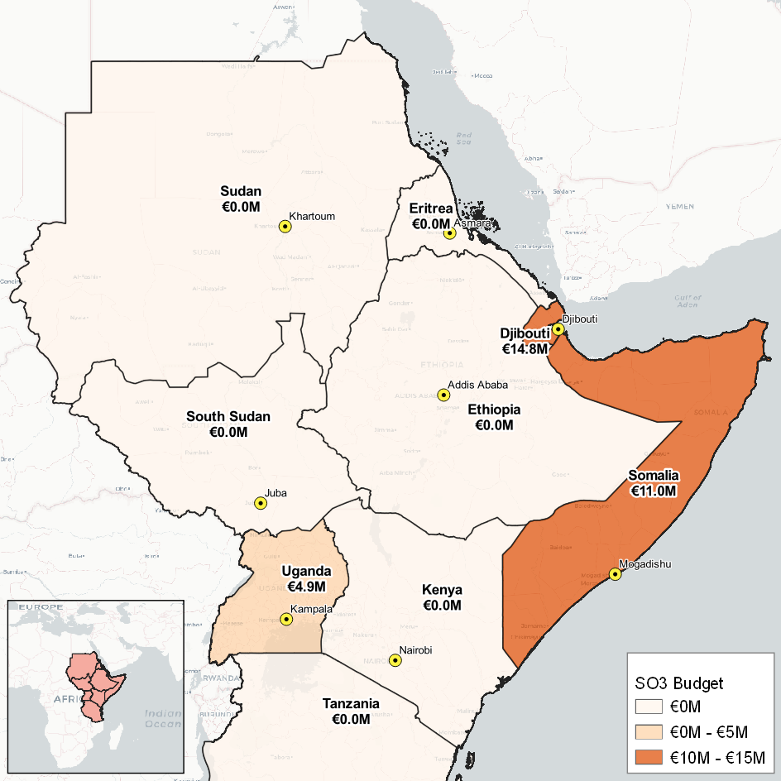

EUTF indicator 3.2 – Number of migrants in transit, victims of human trafficking, children in mobility, IDPs and refugees protected and/or assisted
A total of 46,319 migrants in transit, victims of human trafficking, children in the mobility, IDPs and refugees have been protected or assisted with EUTF funding so far. Three programmes have contributed to this figure: the two regional programmes BMM and Regional Reintegration Facility and RE-INTEG in Somalia. IOM alone has provided assistance upon arrival to 22,456 males and 14,514 females through RE-INTEG, and protected an additional 1,760 male and 249 female migrants in transit through the RRF. BMM allowed for the protection of 201 young migrants in transit (121 males and 80 females) and provided various other services to an additional 5,960 males (including 799 youth) and 1,179 females (including 345 youth).
Figure 40: Number of migrants in transit, victims of human trafficking, children in mobility, IDPs and refugees protected or assisted (EUTF indicator 3.2), by gender and status
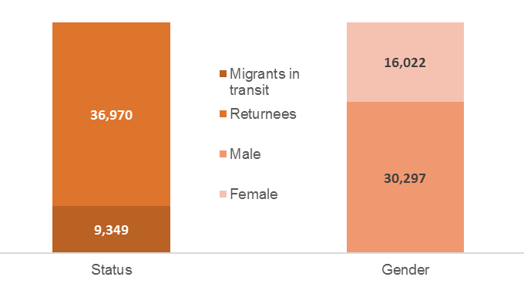
The same three programmes (BMM, the RRF and RE-INTEG) have supported 5,055 voluntary returns or humanitarian repatriations (EUTF indicator 3.4). IOM is responsible for the vast majority of these, with 4,773 repatriations supported between the RRF and RE-INTEG (2,796 males and 1,159 females).
RE-INTEG IOM has provided reintegration assistance to some 20,287 returnees (10,691 males and 9,596 females), BMM to 136 individuals (135 males), and the RRF run by IOM has assisted an additional 221.

EUTF indicator 3.7 – Number of individuals trained on migration management
Figure 41: Number of individuals trained on migration management (EUTF indicator 3.7), by actor and gender
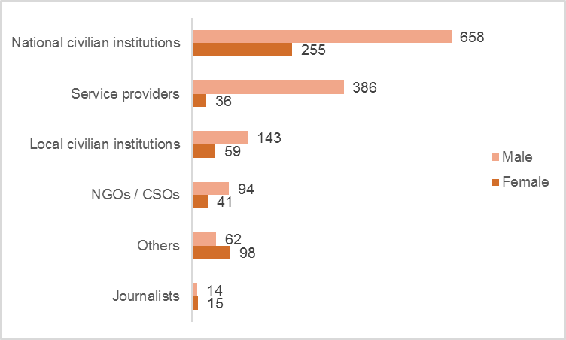
Under SO3, EUTF-funded projects have trained 1,861 individuals on different topics related to the management of borders and flows of migrants. Because migration management is rarely effective when implemented only at the national level, 92% of the trainings have been implemented by regional projects, mostly by BMM. Staff from national and local civilian institutions comprise the bulk (60%) of those trained, which may explain at least in part why the beneficiaries are mostly male. Service providers and NGOs/CSOs also represent a large proportion of the actors trained under this indicator because they often act as first responders before referring migrants to national institutions.

Improved governance and conflict prevention
Strategic Objective 4 is mainly addressed through regional programmes, although the Youth and CVE projects in Kenya are also a key highlight under this SO. RDPP and other programmes in other countries also often include activities related to conflict prevention or peacebuilding. SO4 is covered by 9 EUTF common output indicators.
Figure 42: Countries in the EUTF HoA by funds spent on SO4 – Improved governance and conflict prevention
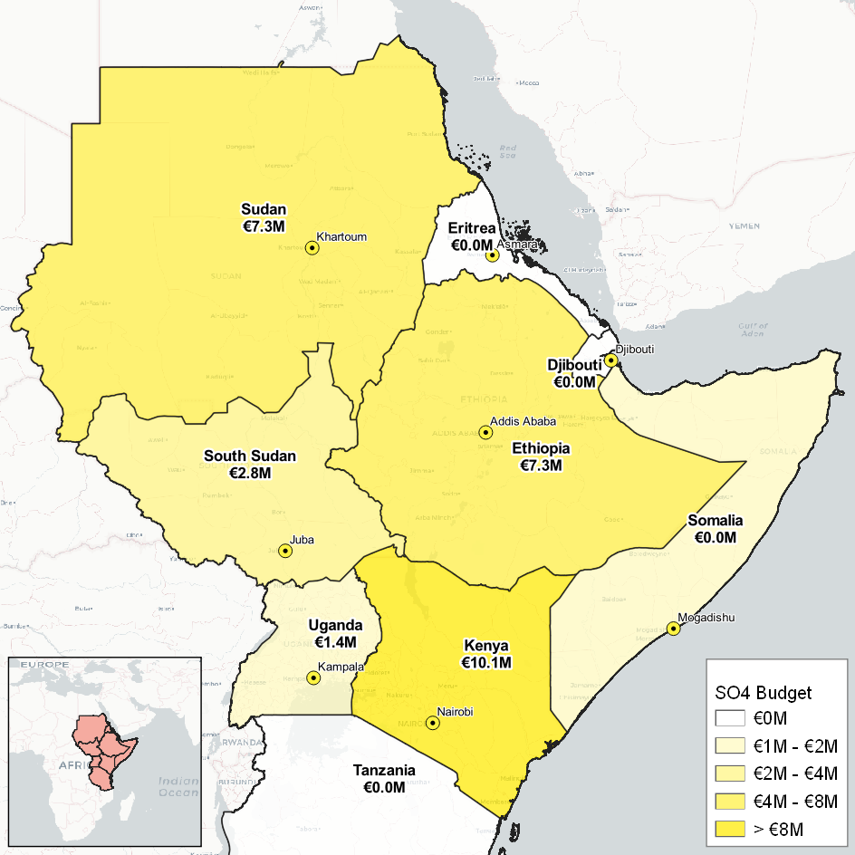

EUTF Indicator 4.3 – Number of people participating in conflict prevention and peace-building activities.
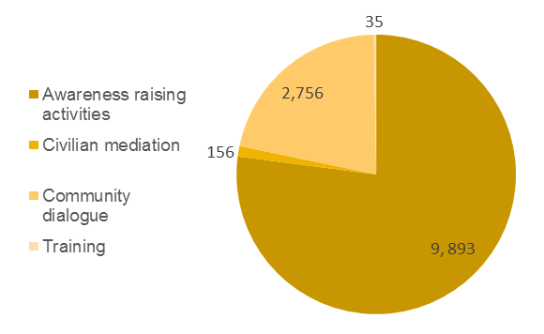
In order to improve governance and counter violent extremism, projects in Somalia, Uganda and Kenya have been implementing a variety of peace-building activities (the 3 countries account for 100% of the activities related to this indicator). Although the activities take many forms, most of them can be classified as awareness raising activities (77%) and community dialogue (21%) along with, to a lesser extent, civilian mediation and trainings.
Figure 43: Number of people participating in conflict prevention and peace building activities (EUTF indicator 4.3), by type of activity
Figure 44: % of people participating in conflict prevention and peace-building activities (EUTF indicator 4.3), by type of beneficiary
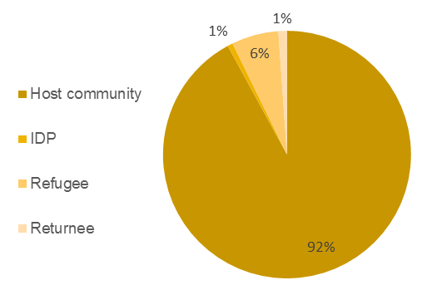

In these countries, it is thought that local youths, who account for 11,507 of the 12,780 total beneficiaries, could fall prey to armed and extremist groups when faced with a lack of economic and employment opportunities. The vast majority of these beneficiaries (10,718) are from the Youth programme on the coast of Kenya, which targets at-risk and vulnerable youth.

Conclusions and perspectives

- A first sketch of the EUTF HoA deployment after two years:
This first regional monitoring report offers a comprehensive picture of the deployment of the activities of the EUTF Horn of Africa after two years. At the regional level, it provides us with a first set of aggregated output data that can be considered as a baseline from which future analyses will be drawn, as many more projects will move into their implementation phase in the next few months and start delivering outputs.
Successful deployment: The EUTF Horn of Africa window covers nine countries, seven of which have active programmes and projects. It has succeeded thus far in committing €846M to the region and in contracting out €516M over 74 projects, among which 43 have started generating outputs. This was achieved in one of the most volatile regions in the world, known for its porous borders, multiple active conflicts and complex mixed migration flows, and all while working in full cooperation and coordination with the region’s governments.
Alignment with strategic objectives: Although projects take time to be identified and launched in such a complex operational environment, the data delivered through this first report already highlights tangible results for the Trust Fund and their alignment with the EUTF’s Strategic Objectives and priorities as expressed by the Strategic Board when the initial set of projects was designed. In particular, the analysis in the report illustrates how the portfolio:
- Combines short-term (cash for work, border posts, protection, reinsertion) and long-term approaches (resilience, improved governance, institution building, human rights, etc.);
- Focuses on both host communities and the most vulnerable people who may be likely to migrate, as well as those who have already migrated, be they IDPs, refugees, migrants or even returnees;
- Addresses issues affecting the youngest population groups via health or education initiatives, the youth most at risk of migrating and / or turning to extremism;
- Promotes and develops sustainable economic opportunities and resilience-building practices to give beneficiaries the chance to build a better future in their country rather than risking the dangers of irregular migration;
- Builds the structural capacities of local governments and institutional partners to develop long-term solutions that will be handed over to local authorities.
Major outputs already delivered: Even though many projects are still in their inception, striking numbers already stand out: 1,588,887 men, women and children under five have received at least one medical consultation in South Sudan thanks to the EUTF’s support to Health Pooled Fund II; over 46,000 migrants in transit, victims of human trafficking, children in the mobility, IDPs and refugees have already been assisted or protected, mostly through BMM, the Regional Reintegration Facility and RE-INTEG programmes; over 20,000 beneficiaries, of whom close to 60% are women, have benefited from professional training and / or skills development; nearly 2,000 individuals have been trained on migration management; and close to 13,000 beneficiaries have been involved in conflict prevention and peace building activities.
Important progress was also achieved with regards to institution building and strengthening, and the development of legal frameworks to address migration issues at national and regional levels is currently in progress. These achievements do not necessarily generate large numbers in terms of outputs but will have a long-term influence that must be highlighted, and this will be further analysed through qualitative case studies by the MLS team.
A complex combination of regional solutions and country-based approaches: EUTF project funding was initially mobilised around regional programmes, and in Ethiopia, a country of both origin and destination of migrants, with one of the highest refugee populations on the continent. Regional programmes account for 32% of the funds contracted so far, reflecting the importance of addressing a regional problem with regional solutions. In addition to this regional approach, however, the analysis of the EUTF HoA portfolio shows us how the response was further crafted around the specific challenges and needs of the different target countries.
The variety of these country profiles and the specificity of the migration crises and instability that they face will continue to require a set of solutions that are both adapted to a rapidly changing environment and deliberately tied into each other, as any solution developed in a given country will have effects across its borders.
This first quarterly report was an opportunity to define the lay of the land, which will progressively be developed to highlight the geographic and structural focuses of EUTF projects and illustrate the breadth of the spectrum covered.
- Perspectives in terms of regional monitoring for EUTF HoA
This first analysis of the regional portfolio of the EUTF leaves a number of questions open, which will progressively be addressed through the collection of project data and the integration of other layers of information.
- Geographic targeting: To what extent do the EUTF projects cover the most significant crises and are specific vulnerable areas or communities left unserved after two years of programming?
- Strategic targeting: Are the different priorities expressed in the initial Strategic Orientation document and refined by the different strategic board meetings adequately reflected by the portfolio? Are some parts of the theory of change underserved?
- Financial distribution: Beyond the initial breakdowns available in this report, how is the funding allocated per specific geographic area, activity and even beneficiary group? What would be the cost of extending or upscaling specific activities?
- Sustainability: How to ensure – and measure – the sustainability of the EUTF-funded initiatives and their fit into the overall migration and development environment and the choice between short-term solutions and long-term investments? How can we reflect these decisions in the aggregation of outputs and outcomes at the regional level, and how can the EUTF HoA ensure a balanced mix of interventions?
- Combination of activities: What is the ideal sequencing and combination of activities (short / long term, relief vs structural) within a given geographic perimeter?
Answering these questions will involve the integration of more complex layers of information that go beyond outputs, in order to better qualify classify and categorise the activities (financial, geographic, duration). The MLS will aim to progressively gather this information once the monitoring system is in place with all Implementing Partners.
- Perspectives for the MLS
Over the next few months, the MLS will continue to work closely with EUTF HoA Implementing Partners, EU delegations and other stakeholders in the region to collect project-related data in the most accurate manner, provide technical assistance on the development of logical frameworks and M&E systems, and collect complementary layers of information through case studies and contextual analysis.
The next quarters will bring new sets of project data and additional outputs for all EUTF common output indicators, and a few more indicators are likely to be added to better reflect the breadth of activities. By the end of 2018, the MLS will start aggregating the first project outcomes in order to measure the collective effects of the funded activities.
In parallel, a number of macro-level indicators will be identified to start tracking changes at the regional level in the fields of migration and stabilisation, in order to analyse correlations with EUTF programming.
Ultimately, the MLS should be used a strategic piloting tool to help EUTF management teams better track efforts, allocate resources and anticipate the amount of effort time required to generate intended changes. Through a better integration of lessons from ongoing projects, the MLS will aim to support more adaptive programming and help to develop the next generations of migration and stabilisation programmes.

Index of figures, tables & focus boxes

Figures
Figure 1: Overview of the different layers of M&E in the HoA region 11
Figure 2: Objectives of the MLS 12
Figure 3: Expected evolution in quantity and depth of information in EUTF quarterly reports 13
Figure 4: Budget contracted and number of contracts by country, May 2018 14
Figure 5: Breakdown of funds and projects included in the Q1 report, May 2018 15
Figure 6: All signed EUTF HOA contracts by budget and status of implementation (74 projects – includes projects in inception and in early phases of implementation as well as 43 projects with data) 18
Figure 7: Breakdown of contracted budget by country and strategic objective, May 2018 19
Figure 8: Scoring of programmes by number of EUTF common output indicators, as of March 2018 21
Figure 9: EUTF common output indicators by number of programmes that inform each indicator, as of March 2018 21
Figure 9: Breakdown of contracted funds by type of implementing partner, May 2018 22
Figure 11: EUTF RDPP funding by country 27
Figure 12: Key programmes and migration flows in Ethiopia, May 2018 28
Figure 12: Number of people receiving a basic social service (EUTF indicator 2.2) in Ethiopia by type of beneficiary 31
Figure 13: Number of social infrastructure built or rehabilitated (EUTF indicator 2.1 bis) in Ethiopia by type of infrastructure 31
Figure 15: Number of people receiving a basic social service (EUTF indicator 2.2) in Ethiopia by type of service 31
Figure 15: Number of jobs created (EUTF indicator 1.1) in Ethiopia, by gender and type of job 32
Figure 17: REAL’s contributions to the four pillars of the EU ‘basic resilience model’ in Ethiopia 35
Figure 18: Key programmes and migration flows in South Sudan, May 2018 36
Figure 19: Key programmes (by budget) and migration flows in Sudan, May 2018 43
Figure 19: Number of people receiving food security related assistance (EUTF indicator 2.4) in Sudan, by type of beneficiary 46
Figure 20: Number of people assisted to develop economic income-generating activities (EUTF indicator 1.3) in Sudan, by gender 46
Figure 22: Key programmes and migration flows in Somalia, May 2018 49
Figure 23: No of beneficiaries assisted to develop IGAs (EUTF indicator 1.3) by beneficiary type and gender 53
Figure 24: People provided with a basic service (EUTF indicator 2.2) in Somalia, by beneficiary status and gender 53
Figure 25: Key programmes and migration flows in Kenya, May 2018 54
Figure 26: Number of people receiving a basic social service (EUTF indicator 2.2) in Kenya, by type of service 56
Figure 27: Number of people receiving food security assistance (EUTF indicator 2.4) in Kenya, by gender 56
Figure 27: Number of jobs created (EUTF indicator 1.1) in Kenya, by gender and type of activity 57
Figure 28: Number of people participating in conflict-prevention and peace-building activities (EUTF indicator 4.3) in Kenya by type of activity 57
Figure 30: Key programmes and migration flows in Uganda, May 2018 61
Figure 31: Beneficiaries of professional trainings (TVET) and/or skills development trainings (EUTF indicator 1.4), by status and gender 64
Figure 32: Staff trained on conflict prevention, border management and human rights (EUTF indicator 4.2) by displacement status and training topic 64
Figure 33: Key programmes and migration flows in Djibouti, May 2018 68
Figure 33: Countries in the EUTF HoA by funds spent on SO1 - Greater economic and employment opportunities 70
Figure 35: Number of jobs created and/or supported (EUTF indicator 1.1), disaggregated by type of job 71
Figure 35: Number of people benefiting from professional training (TVET) and/or skills development (EUTF indicator 1.4), disaggregated by country 71
Figure 36: Countries in the EUTF HoA by funds spent on SO2 – Strengthening resilience of communities 72
Figure 38: Number of social infrastructures built or rehabilitated (EUTF indicator 2.1b), by type of infrastructure 73
Figure 39: Countries in the EUTF HoA by funds spent on SO3 – Improved migration management 74
Figure 40: Number of migrants in transit, victims of human trafficking, children in mobility, IDPs and refugees protected or assisted (EUTF indicator 3.2), by gender and status 75
Figure 41: Number of individuals trained on migration management (EUTF indicator 3.7), by actor and gender 76
Figure 42: Countries in the EUTF HoA by funds spent on SO4 – Improved governance and conflict prevention 77
Figure 42: Number of people participating in conflict prevention and peace building activities (EUTF indicator 4.3), by type of activity 78
Figure 43: % of people participating in conflict prevention and peace-building activities (EUTF indicator 4.3), by type of beneficiary 78

Tables
Table 1: EUTF HoA projects implementing and with data to report 15
Table 2: Targets and results achieved so far by EUTF common output indicator, March 2018 20
Table 3: BMM – Key facts and figures 23
Table 4: BMM – Key indicators (results achieved as of March 2018) 23
Table 5: RRF – Key facts and figures 24
Table 6: RRF – Key indicators (results achieved as of March 2018) 24
Table 7: IGAD Resilience – Key facts and figures 25
Table 8: IGAD Resilience – Key indicators (results achieved as of March 2018) 25
Table 9: RDPP – Key indicators (results achieved as of March 2018) 27
Table 10: Ethiopia – Key facts and figures 30
Table 11: Ethiopia – Key indicators (results achieved as of March 2018) 30
Table 12: RDPP ET – Key facts and figures 33
Table 13: RDPP ET – Key indicators (results achieved as of March 2018) 33
Table 14: RESET II – Key facts and figures 34
Table 15: RESET II – Key indicators (results achieved as of March 2018) 34
Table 16: South Sudan – Key facts and figures 37
Table 17: South Sudan – Key indicators (results achieved as of March 2018) 38
Table 18: HPF II – Key facts and figures 39
Table 19: HPF II – Key indicators (results achieved as of March 2018) 39
Table 20: IMPACT – Key facts and figures 40
Table 21: IMPACT – Key indicators (results achieved as of March 2018) 40
Table 22: Economic Stabilisation – Key facts and figures 41
Table 23: Economic Stabilisation – Key indicators (results achieved as of March 2018) 42
Table 24: Sudan programmes not included in this report 44
Table 25: Sudan – Key facts and figures 45
Table 26: Sudan – Key indicators (results achieved as of March 2018) 46
Table 27: RDPP SD – Key facts and figures 47
Table 28: RDPP SD – Key indicators (results achieved as of March 2018) 47
Table 29: El Niño SD – Key facts and figures 48
Table 30: El Niño SD – Key indicators (results achieved as of March 2018) 48
Table 31: Somalia – Key facts and figures 50
Table 32: Somalia – Key indicators (results achieved as of March 2018) 51
Table 33: RE-INTEG Somalia – Key facts and figures 52
Table 34: Kenya – Key facts and figures 55
Table 35: Kenya – Key indicators (results achieved as of March 2018) 56
Table 36: RDPP Kenya – Key facts and figures 58
Table 37: RDPP Kenya – Key indicators (results achieved as of March 2018) 58
Table 38: Youth Kenya – key facts and figures 59
Table 39: Youth Kenya – Key indicators (results achieved as of March 2018) 59
Table 40: Uganda – Key facts and figures 62
Table 41: Uganda – Key indicators (results achieved as of March 2018) 63
Table 42: RDPP SPRS-NU – Key facts and figures 65
Table 43: RDPP SPRS-NU – Key indicators (results achieved as of March 2018) 66
Table 44: Livelihood groups indicators, RDPP SPRS-NU DRC 66
Table 45: SSCoS – Key facts and figures 67
Table 46: SSCoS – Key indicators (results achieved as of March 2018) 67
Table 47: Djibouti – Key facts and figures 69

Focus boxes
Focus box 1: Introduction to the IGAD case study: focus on EUTF projects and institution building 26
Focus box 2: The EU Regional Development and Protection Programme (RDPP) 26
Focus box 3: RESET II Specificities 34
Focus box 4: Key findings from RESET II Case study: an integrated approach to resilience building 35
Focus box 5: Some RE-INTEG highlights 52
Focus box 6: Introduction to the MLS case study on the Conflict prevention, peace and economic opportunities for the youth in Kenya programme 60
Focus box 7: RDPP SPRS-NU DRC’s livelihood groups 66

Valletta Summit Action Plan, 2015.
Programmes are also called decisions or actions and can have several contracts which are also called projects.
EUTF Strategic Orientation Document, 2016.
IOM, Horn of Africa: A region on the move, 2017. Depending on the source and due to country-level differences in defining refugees or IDPs, other estimates may be much higher.
These are the contributions made to the EUTF after deduction of administrative costs.
Actual number of projects in Q1 report is 38, exceeding expectations by 8 projects.
One project under 100,000€ not represented. 42 projects represented. Projects in grey italics are not in the report.
The contract was signed with CW to address the drought and the resulting mass displacement in Baidoa. This additional grant focuses exclusively on Baidoa (Bay region), while the first grant focuses on Baidoa and Afgoye (Shabeellaha Hoose region).
Four projects with budgets below €1M (RE-INTEG DRC, Eco. Stabilization ECORYS, Tolerance BC, SINCE Ernst & Young) were omitted. All of these would be blue / ‘completed’ in the chart. Shortened names were used for simplicity’s sake in the legend; the equivalent ‘long’ names can be found in the report’s Annex. Budgets are solely EUTF contribution. The length of the bars represents the lifespan of the project and the height/width the EUTF budget per project.
The darker the country map the more funds spent in the country.
Indicators not represented have neither targets nor data so far. When some of the IPs did not provide targets and the results achieved are therefore much higher than existing targets, ‘% achieved’ is capped at 100%.
The MLS and REF are not included as they are quite different in nature.
IOM, Horn of Africa: a region on the move, 2017.
IDDRSI, the IGAD Drought Disaster Resilience and Sustainability Initiative, is a 15-year initiative (2012-2027) to improve the resilience of arid and semi-arid communities to drought.
Fiche Action for the implementation of the Horn of Africa window EUTF05 – HoA – REG – 20.
REINTEG Somalia is sometimes considered under the umbrella of RDPP, but has not been included in the RDPP focus box.
It was not possible to identify the displacement status for 4% of the beneficiaries.
UNHCR Ethiopia Factsheet, March 2018.
Government of Ethiopia, ‘Ethiopia working to improve refugees’ access to education’.
UNHCR, ‘New Ethiopia policy helps refugees legally document life events’.
EU Horn of Africa Operational Framework.
ILO, ‘Addressing the root causes of migration in Ethiopia’.
Ibid.
EU Horn of Africa Operational Framework.
All figures from IOM, ‘A Region on the Move: Migration trends in the East and Horn of Africa, 2017’, except number of refugees (from UNHCR Ethiopia Factsheet, March 2018).
See above description of the 6 programmes not included in this report.
Access to services is measured by the number of people who potentially benefit from an improved service, such as the catchment population of a rehabilitated health facility or of a constructed water point. It does not necessarily mean that these people actively use the improved service to which they have access.
According to the Shire Alliance Action Document, only 27% of Ethiopians have access to the national grid, which is among the lowest rates globally.
IGAs are only considered a ‘job created’ if and when the beneficiary actually generates income from the activity.
Note that IMPACT covers the whole country.
South Sudan Situation – Regional Update, UNHCR, February 2018.
Ibid.
South Sudan Regional Refugee Response Plan, UNHCR, January – December 2018.
UN DESA, 2017, unless specified otherwise.
UN DESA, 2016.
UNHCR, 2018.
UNHCR, May 2018.
UNDP, 2015.
Figures reported in this report for HPFII are proportional to EUTF’s contribution to the overall budget of the Programme, estimated at 11.4% The estimated percentage is not 13.3% (20mln/150mln), because based on exchange rates at time of signature.
Access to services is measured by the number of people who potentially benefit from an improved service, such as the catchment population of a rehabilitated health facility or of a constructed water point. It does not necessarily mean that these people actively use the improved service to which they have access.
Beneficiaries under indicator 2.2 are people provided with health under HPFII, while those under 2.9 are children who gained improved access to schools thanks to the incentives to teachers in IMPACT. The health recipients under 2.2. are not counted again in 2.9.
Fiche Action Health Pooled Fund II.
See previous comment on Access. In this case, the ratio of teachers to students is 50:1 as given by the Government of South Sudan.
Final evaluation – Technical assistance for sub-national capacity building in payroll and PFM (EUTAPP), AECOM, 2016.
The circle on West Darfur represents an area of IDP camps where some of the EUTF-funded programmes will work. The breakdown of budget by State as been approximated when detailed budget were not available.
IOM World Migration report, 2018.
Ibid.
ECHO Factsheet, October 2017, since UNHCR added 350,000 South Sudanese to the number of refugees we can expect this number to have gone up.
UNHCR, South Sudan Population Dashboard, April 2018 – this number includes 350,000 South Sudanese who arrived in Sudan between 2011 and 2013.
UNHCR, Population statistics, 2016.
Sudan EUD, based on Sudan government sources.
Excluding funds from regional projects which tend to be more oriented towards SO 3 ‘Improving migration management’ and SO4 ‘Improving governance’, such as BMM or the RRF.
The IPs for which no contract had been signed as of March 2018 are in italics in the table.
UN Population division, DESA, 2017.
The IDP settlements marked in the map are the main settlements targeted by RE-INTEG, and they are not an exhaustive list of the existing ones in Somalia.
Mapping the devastation of Somalia’s drought, UN Environment, 2018.
Mortality among populations of southern and central Somalia affected by severe food insecurity and famine during 2010–2012. Somalia: Food Security and Nutrition Analysis Unit, 2013, FAO/FSNAU, FEWS-NET.
UNHCR, January 2018.
IOM Displacement Tracking Matrix, May 2018.
Repatriation Update, UNHCR, March 2018.
Mixed Migration in the Horn of Africa and in the Arab Peninsula: IOM Regional Office for the East and Horn of Africa.
Saudi Gazzette, December 2017.
UN DESA, 2017, unless specified otherwise.
UN DESA, 2016.
UNHCR, January 2018.
Repatriation Update, UNHCR, March 2018.
RE-INTEG, Promoting a culture of tolerance, RESTORE / El Niño, Security and rule of law, RESTORE 2.
CW’s EIDACS project consists of two contracts.
UNHCR data for end January 2018.
UNHCR Operational update on Dadaab, January 2018.
UNHCR Kenya, Kalobeyei integrated settlement and Kakuma refugee camp, January 2018.
UNHCR Operational update on Dadaab, January 2018.
IOM, Horn of Africa: A region on the move, 2018.
World Bank estimation, 2013.
UNDP, HDI ranking, 2016
UNHCR, April 2018.
Refugees flee fresh fighting in Congo to Uganda, UNHCR, February 2018.
World Bank, 2016.
UN DESA, 2017, unless specified otherwise.
UN DESA, 2016.
UNHCR, 2018.
UNDP, 2015.
For cash for work and short-term jobs, a job is calculated by aggregating the days worked by different beneficiaries.
UNHCR, 2018.
This figure does not include all jobs created within this project (1,750), but only the ones within the livelihood groups.
UNHCR, ‘UNHCR welcomes Djibouti’s new refugee laws’.
World Bank, ‘Djibouti’s Economic Outlook – October 2017’.
EU Horn of Africa Operational Framework.
IOM, ‘A Region on the Move: Migration trends in the East and Horn of Africa, 2017’.
This figure includes all types of migrants.
The figures for HPF II refer to the period April 2016 – December 2017.
The figures are calculated as a % of EUTF’s contribution to the overall budget of the Programme, estimated at 11.4%.
Gender disaggregation of returnees supported by the RRF was not available.
Included in voluntary return and repatriation is short term assistance upon return (temporary housing, basic medical services…) while reintegration and reinsertion assistance can include more long term support (TVET, language courses etc.).

